MANUAL TESTING

Module 1: Login Page
TC ID | Test Case | Test Data | Expected Result | Status
MT-01 | Open Sign In page | Click Sign In from header | Sign In page opens with Email Address, Password, and Sign In button | Executed
MT-02 | Login with valid customer | Registered customer email + correct password | Customer is logged in and username dropdown is visible | Executed
MT-03 | Login with valid admin | admin@email.com + correct password | Admin is logged in and Admin dropdown is visible | Executed
MT-04 | Login with invalid password | Registered email + wrong password | Error message is displayed and user stays on Sign In page | Executed
MT-05 | Login with invalid email | Unregistered email + valid password | Login fails and error message is displayed | Executed
MT-06 | Submit empty form | Email blank + password blank | Browser validation or application validation prevents submission | Executed
MT-07 | Invalid email format | ahmdgmail.com | Email field validation prevents invalid format | Executed
MT-08 | Logout from account | Logged-in user clicks Logout | User is logged out and redirected to Sign In page | Executed

Screenshots / Visual Proof
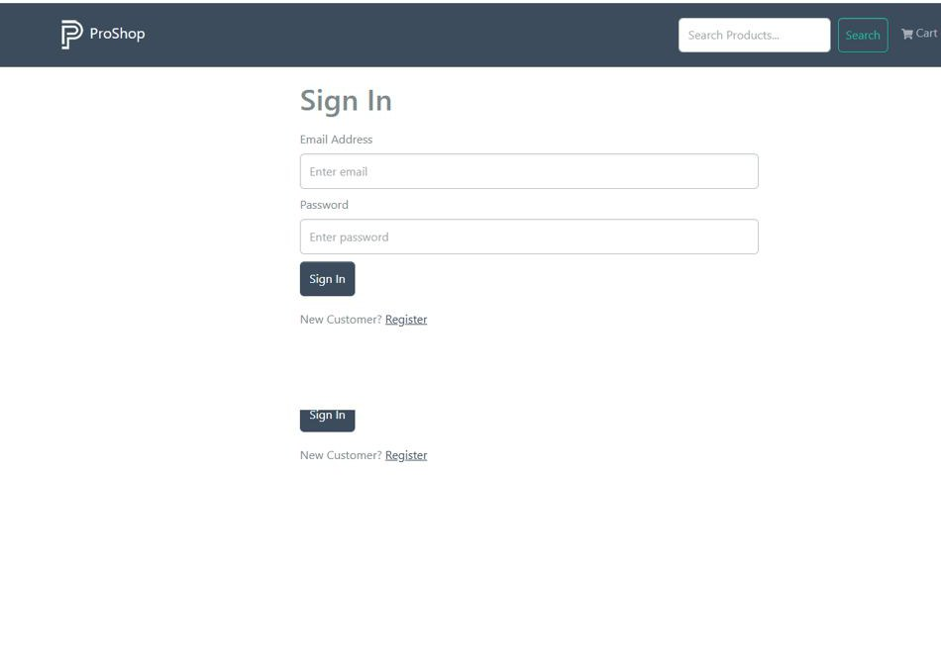Screenshot Proof: MT- 02
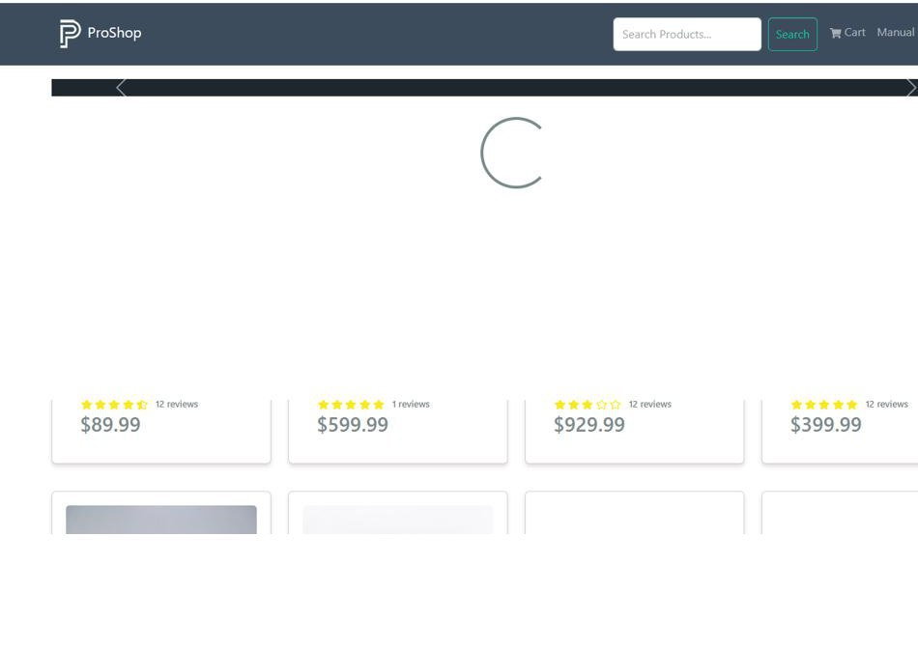Screenshot Proof: MT- 03
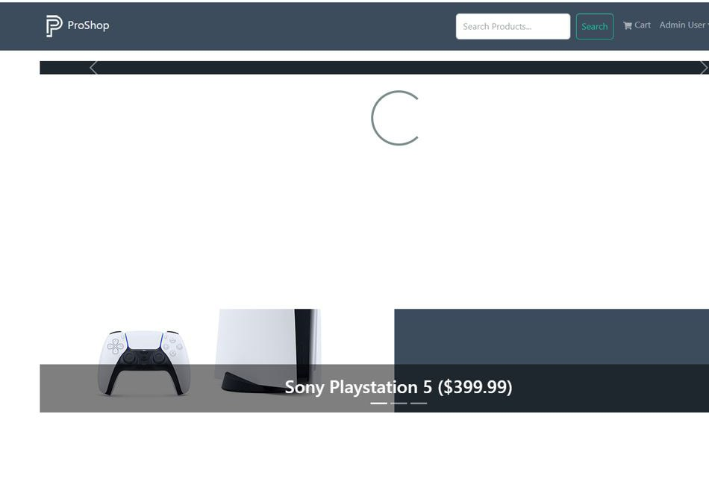Screenshot Proof: MT -04
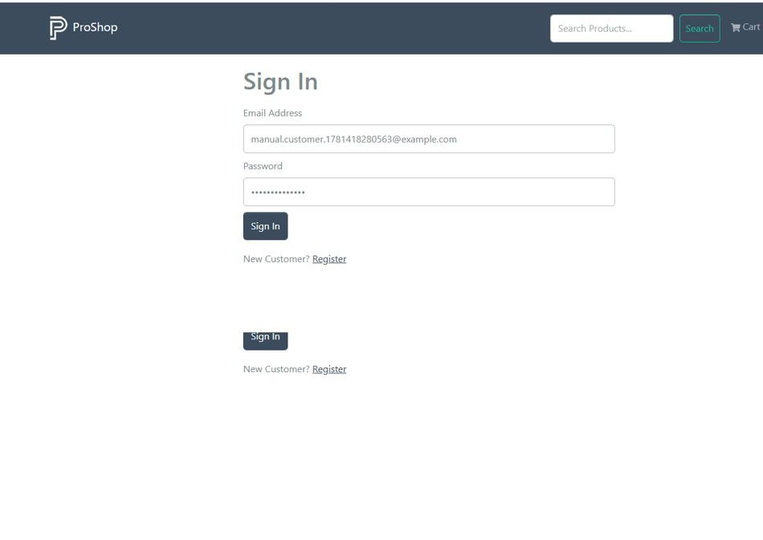Screenshot Proof: MT- 05
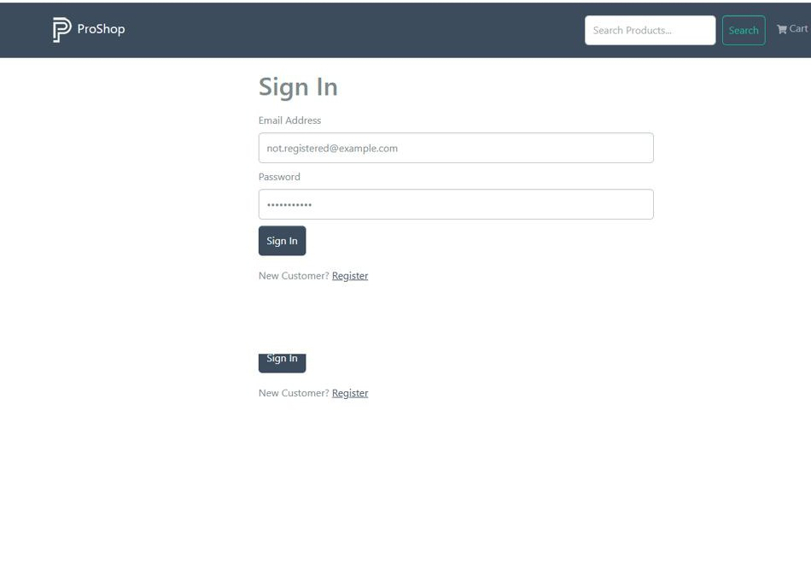Screenshot Proof: MT-06
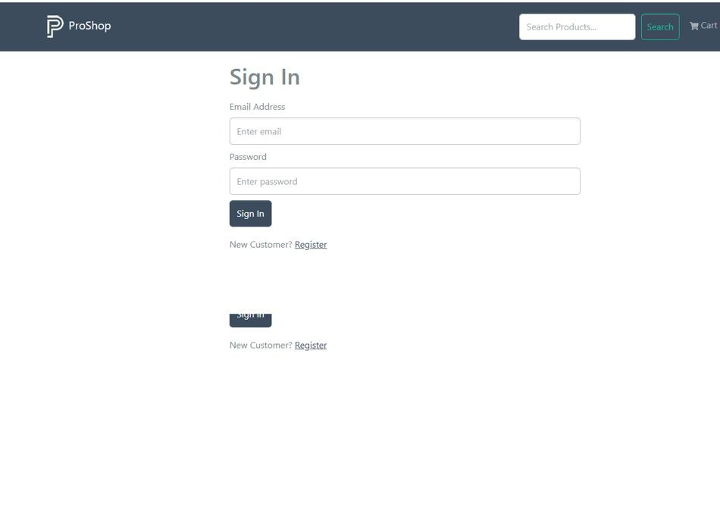Screenshot Proof: MT-07
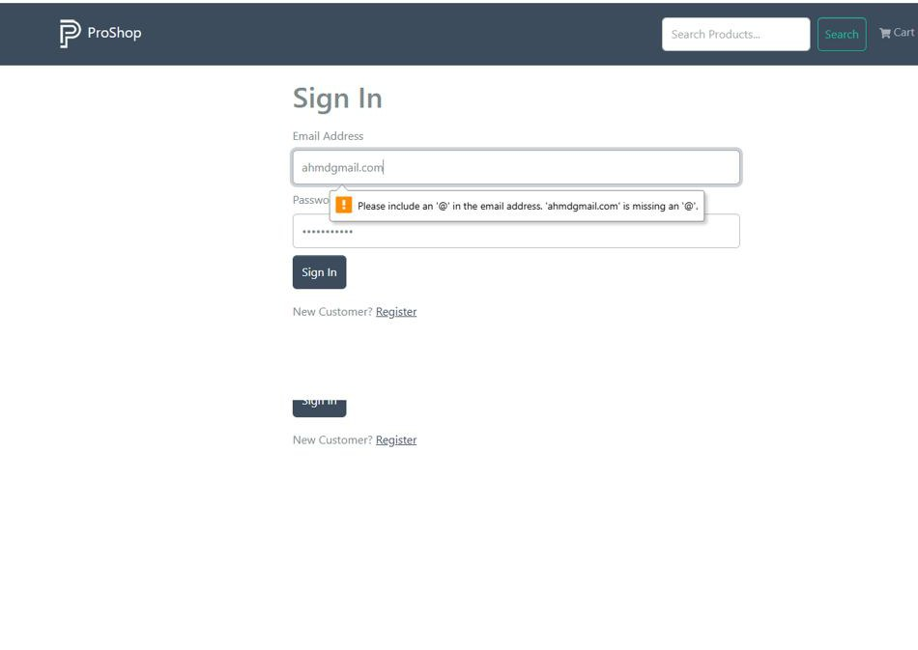Screenshot Proof: MT-08

Module 2: User Registration
TC ID | Test Case | Test Data | Expected Result | Status
MT-01 | Open Register page | Click Register link from Sign In page | Register page opens with name, email, password, and confirm password fields | Executed
MT-RG-02 | Register valid user | New name, new email, password, confirm password | Account is created and user is logged in | Executed
MT-RG-03 | Register duplicate email | Existing email address | Application shows user already exists error | Executed
MT-RG-04 | Password mismatch | Password and confirm password different | Registration is rejected with password mismatch message | Executed
MT-RG-05 | Empty required fields | Leave all fields blank | Required field validation prevents registration | Executed
MT-RG-06 | Invalid email during registration | abcgmail.com | Email format validation is shown | Executed
MT-RG-07 | Short password | Password less than expected length | System rejects or securely handles weak password | Executed
MT-RG-08 | Navigate back to login | Click Sign In link | User is redirected back to Sign In page | Executed

Screenshots / Visual Proof
Screenshot Proof: MT-01
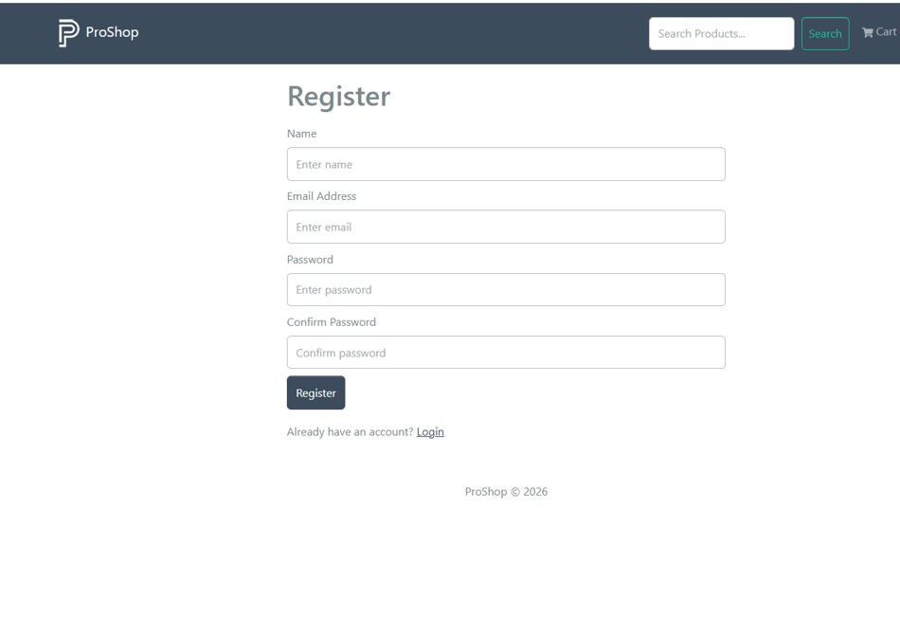Screenshot Proof: MT-02
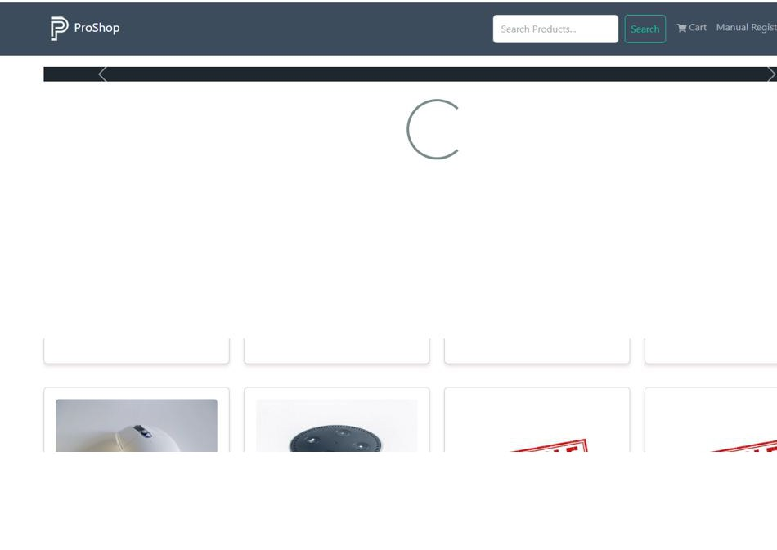Screenshot Proof: MT-03
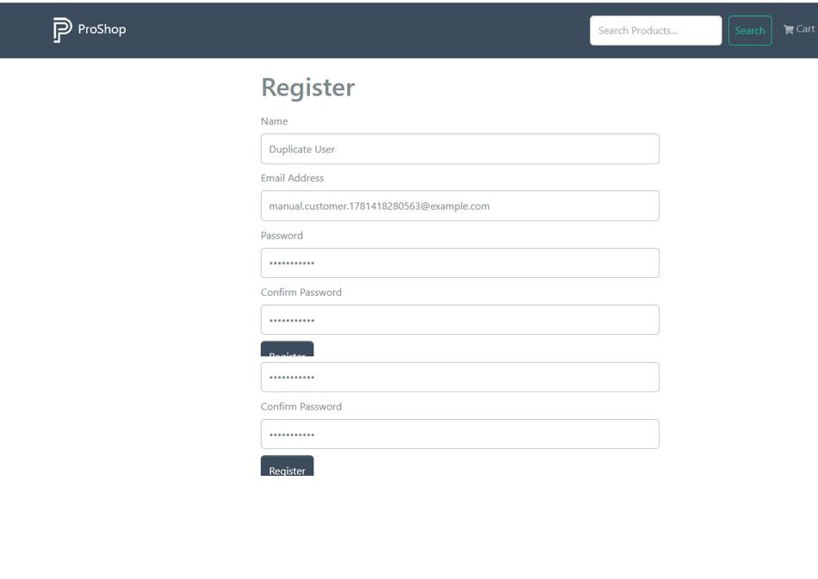Screenshot Proof: MT-04
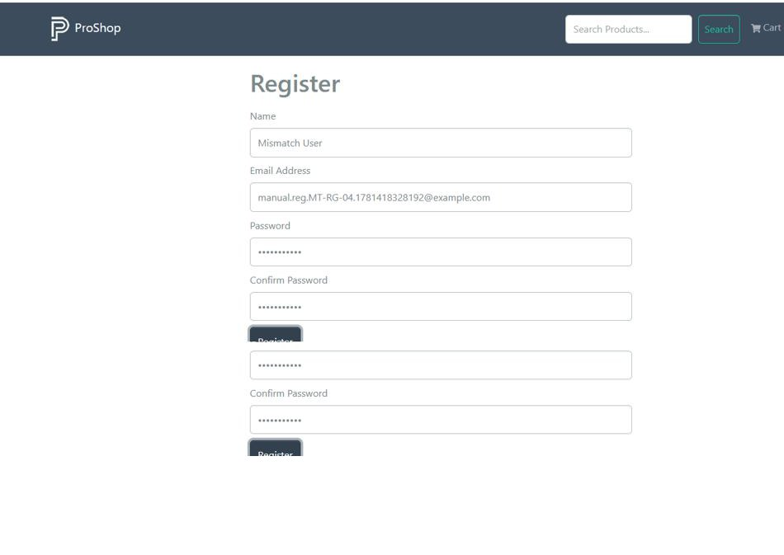Screenshot Proof: MT-05
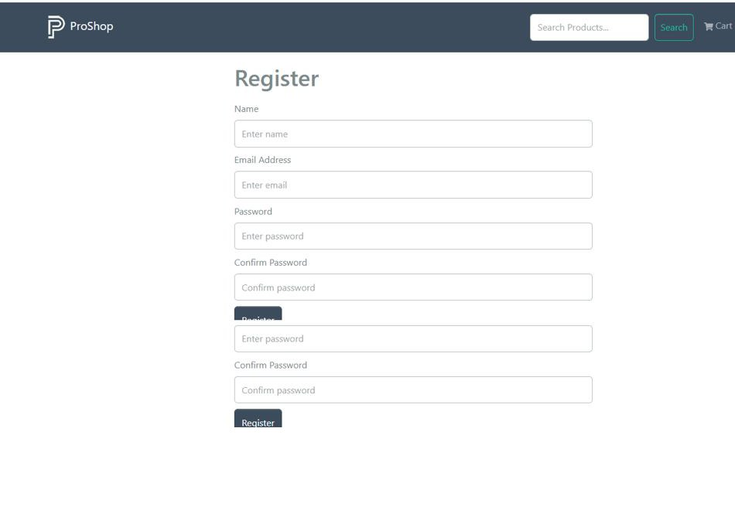Screenshot Proof: MT-06
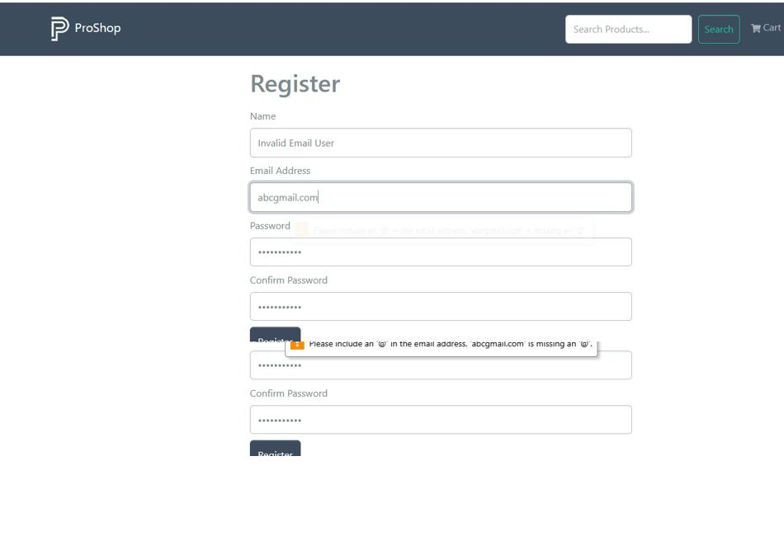Screenshot Proof: MT-07
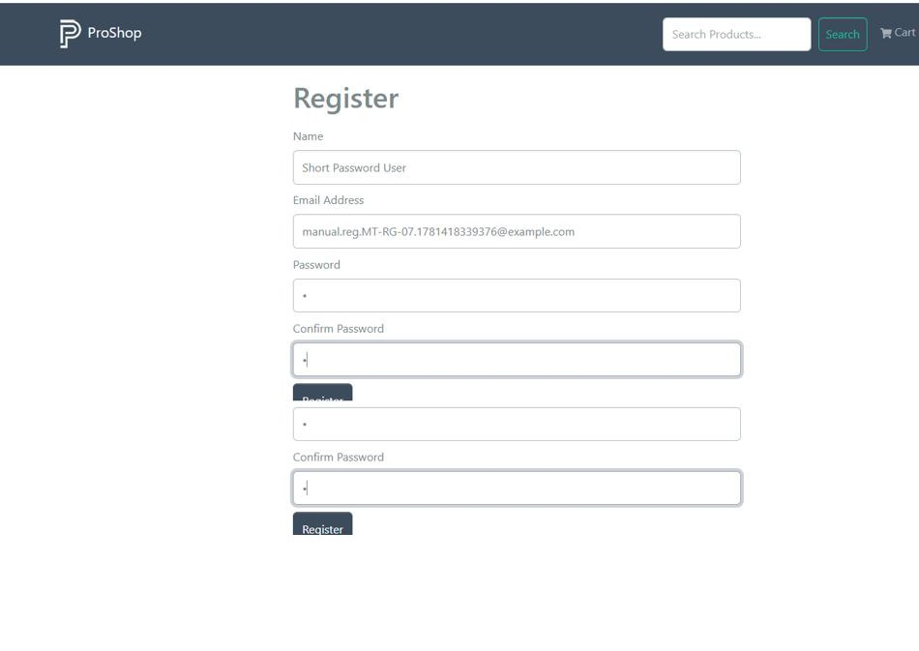Screenshot Proof: MT-08

Module 3: Home Page / Product Listing
TC ID | Test Case | Test Data | Expected Result | Status
MT-HP-01 | Open home page | Browse live URL | Home page loads with ProShop header and Latest Products section | Executed
MT-HP-02 | Verify product cards | Home page products | Each product card displays image, name, rating, reviews, and price | Executed
MT-HP-03 | Open product from card | Click iPhone product name/image | Product detail page opens for selected product | Executed
MT-HP-04 | Check top carousel | Home page carousel | Top product carousel is visible and can be navigated | Executed
MT-HP-05 | Pagination display | Product list with pages | Pagination controls appear when products exceed page limit | Executed
MT-HP-06 | Use pagination | Click page number | Selected product page opens and products update | Executed
MT-HP-07 | Header cart link | Click Cart from header | Shopping Cart page opens | Executed
MT-HP-08 | Header brand link | Click ProShop logo | User returns to home page | Executed

Screenshots / Visual Proof
Screenshot Proof: MT-01
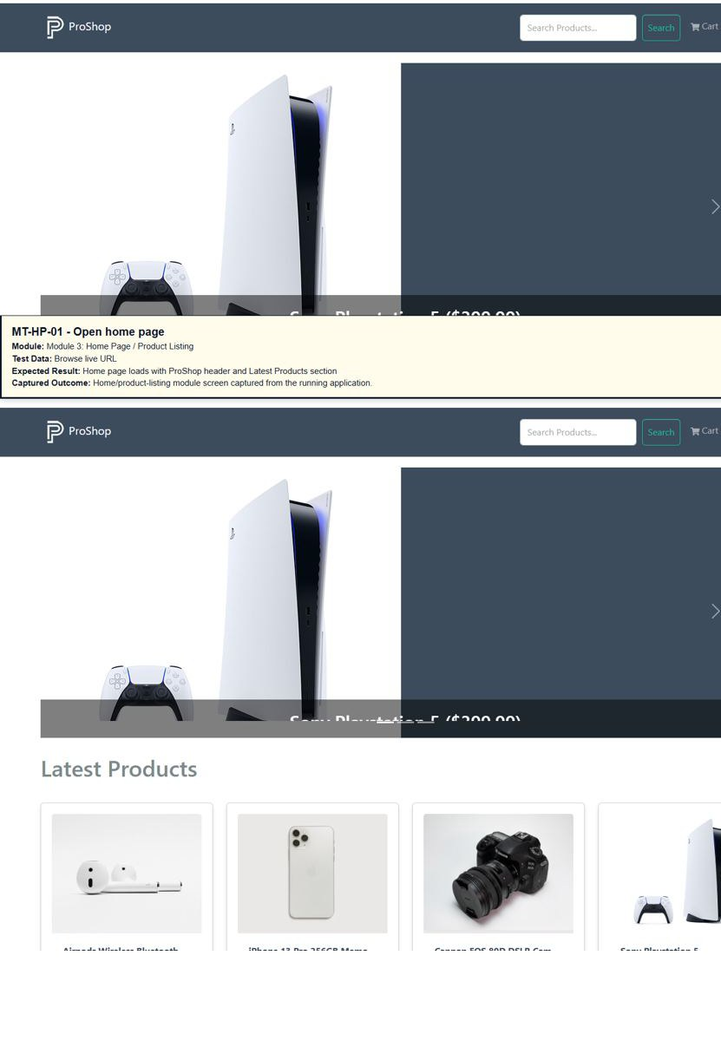
Screenshot Proof: MT-02 - Verify product cards
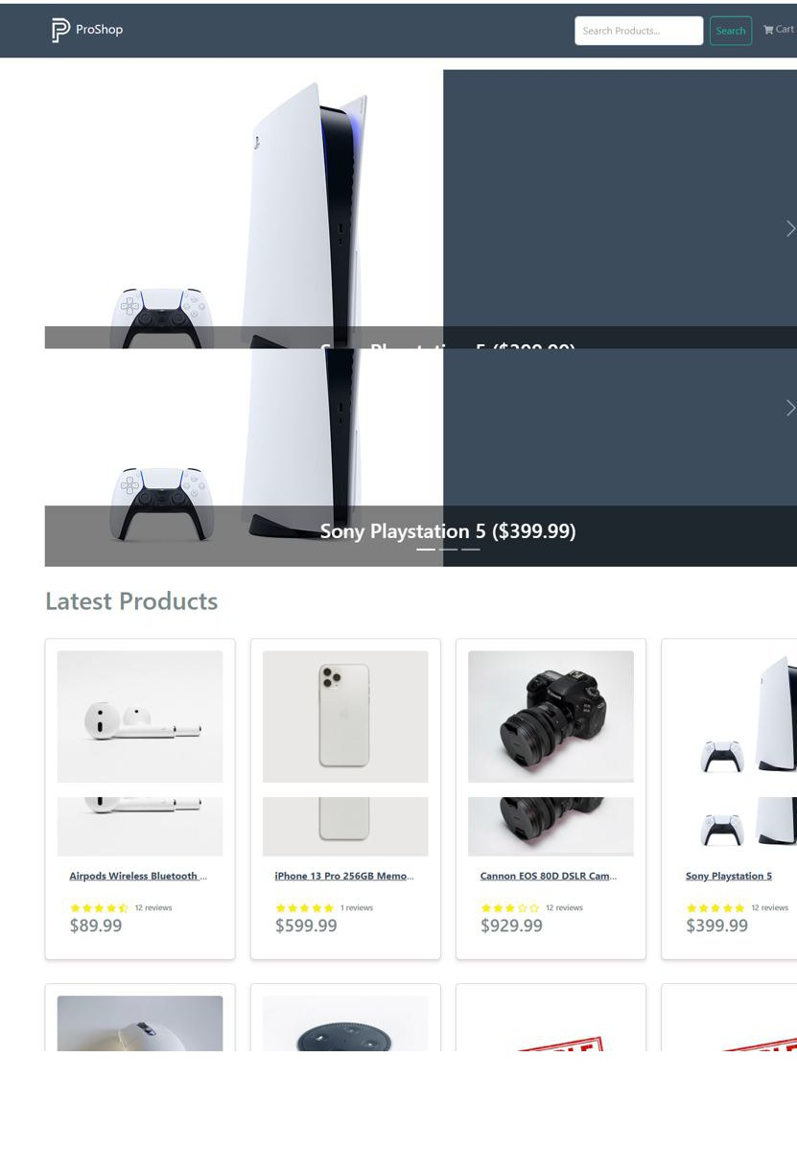
Screenshot Proof: MT-03
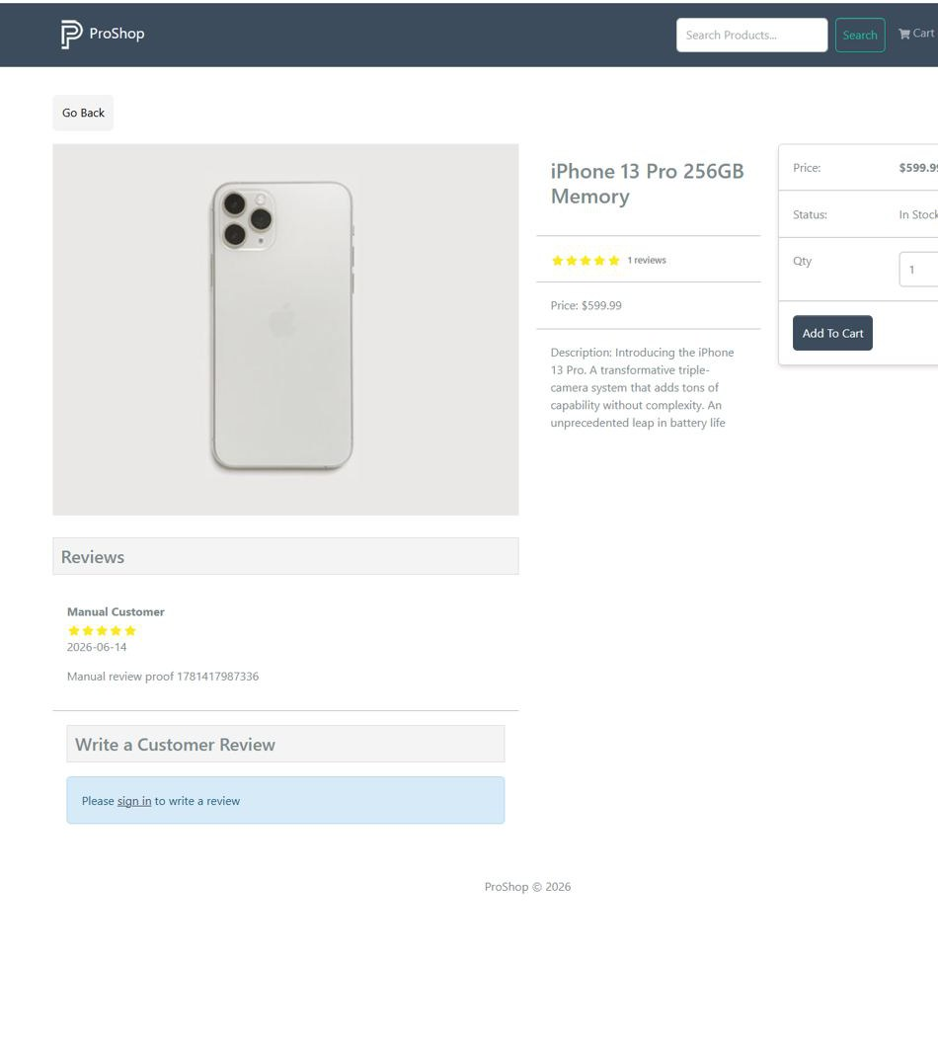Screenshot Proof: MT-04
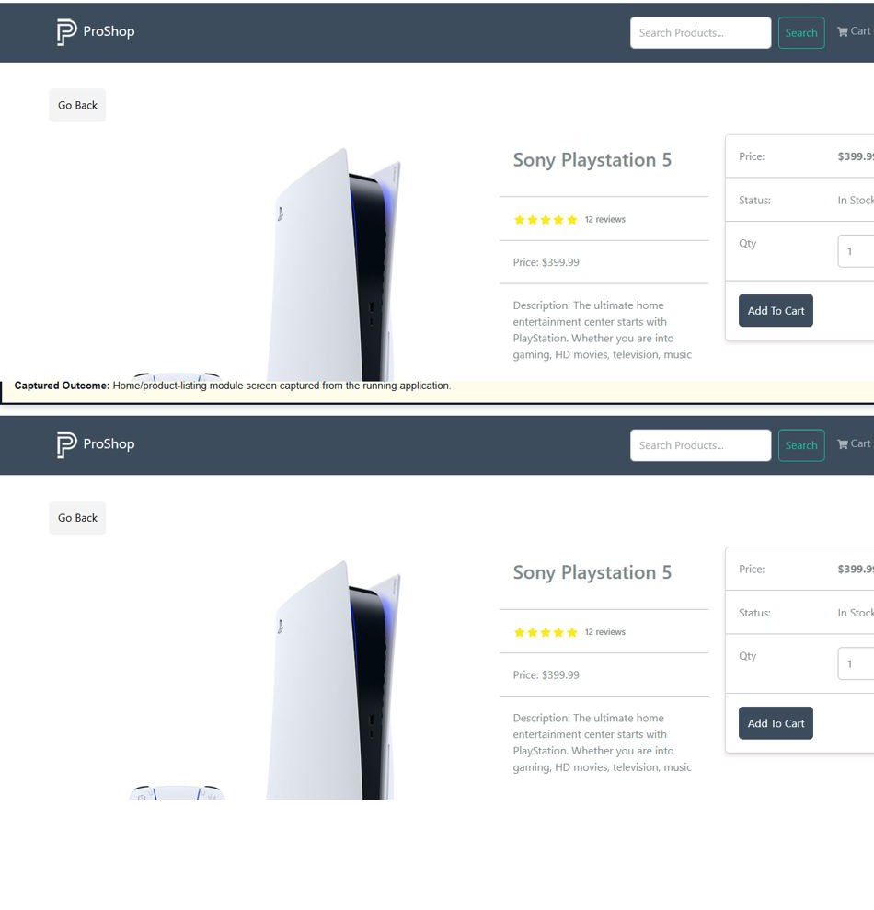Screenshot Proof: MT-05
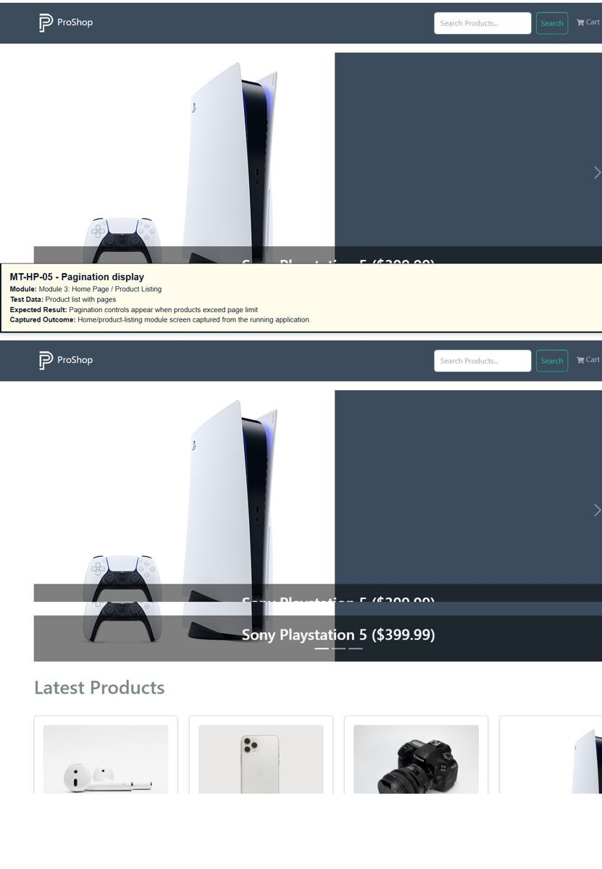
Screenshot Proof: MT-06
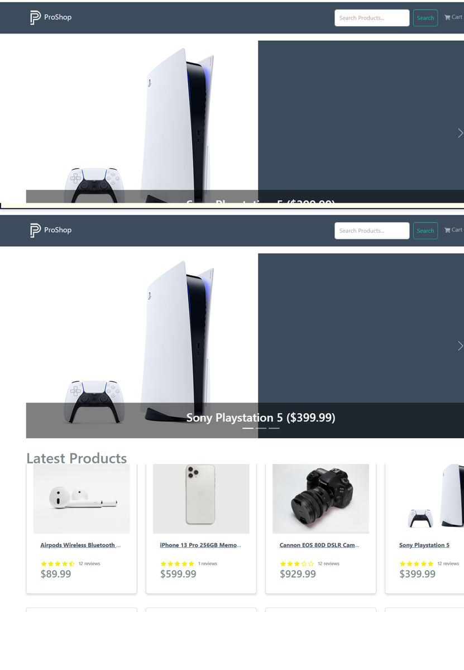
Screenshot Proof: MT-07
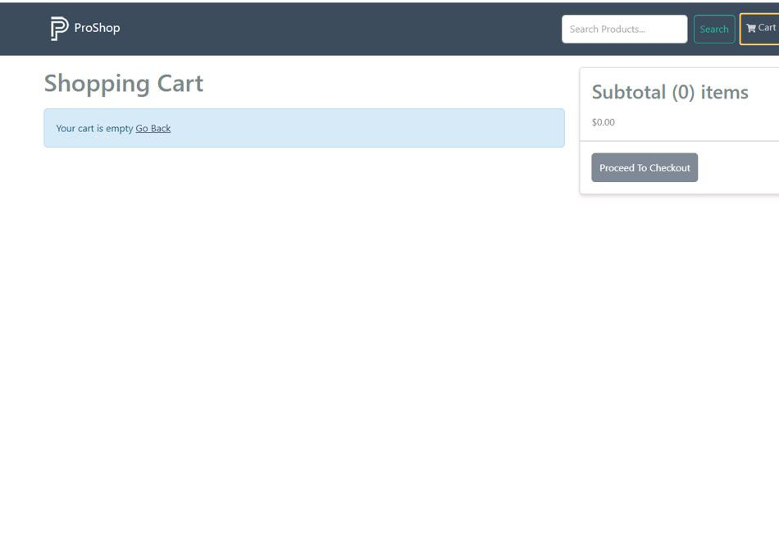Screenshot Proof: MT-08

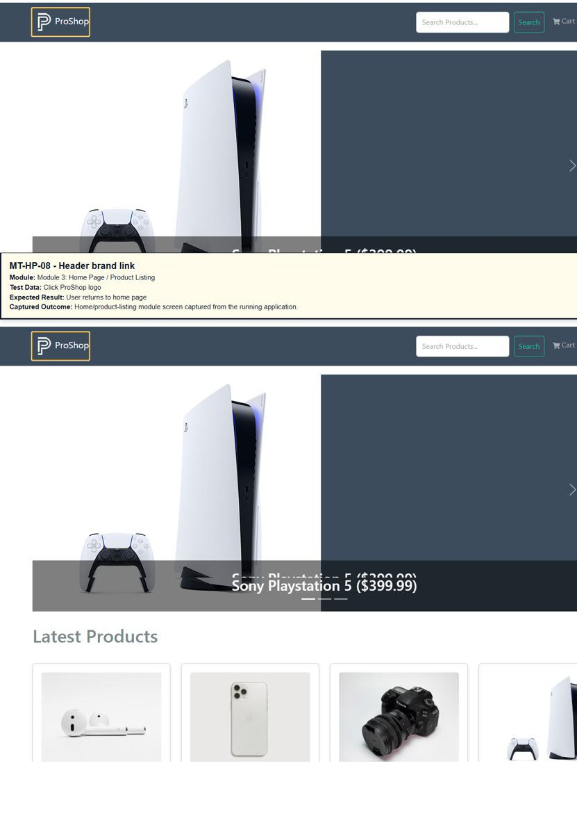

Module 4: Product Details
TC ID | Test Case | Test Data | Expected Result | Status
MT-PD-01 | View in-stock product | Open iPhone product | Product page shows image, description, price, status, quantity, and Add To Cart button | Executed
MT-PD-02 | View out-of-stock product | Open Amazon Echo Dot | Status shows Out Of Stock and Add To Cart button is disabled | Executed
MT-PD-03 | Change quantity | Select quantity 2 | Selected quantity changes before adding to cart | Executed
MT-PD-04 | Add product to cart | Click Add To Cart | Cart page opens with selected product and quantity | Executed
MT-PD-05 | Use Go Back | Click Go Back on product page | User returns to previous/home page | Executed
MT-PD-06 | Review section for guest | Guest opens product page | Message asks user to sign in to write a review | Executed
MT-PD-07 | Submit valid review | Logged-in user selects rating and comment | Review is submitted or proper duplicate-review message is displayed | Executed
MT-PD-08 | Submit empty review | Logged-in user leaves review fields blank | Required validation prevents review submission | Executed

Screenshots / Visual Proof
Screenshot Proof: MT-01
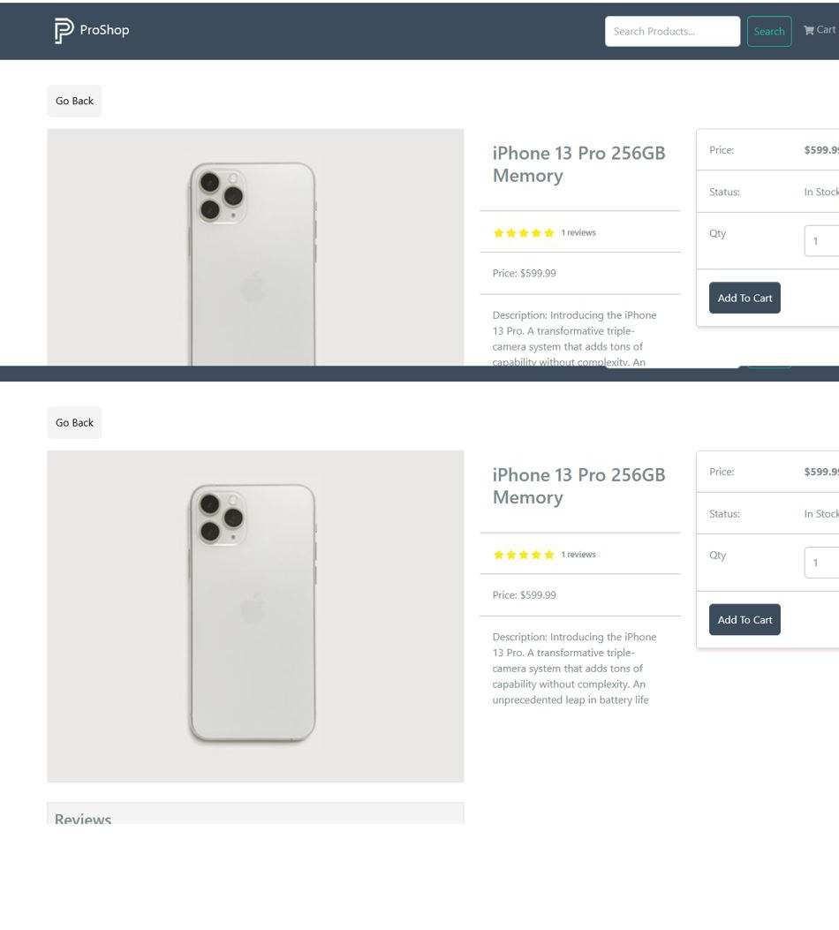Screenshot Proof: MT-02
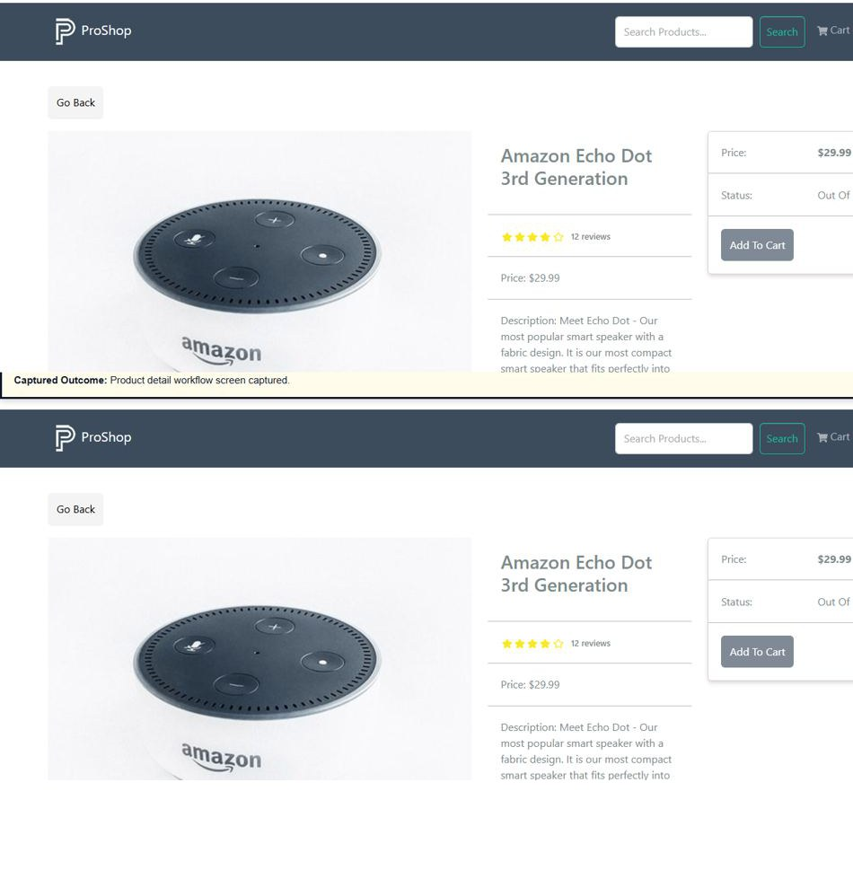Screenshot Proof: MT-03
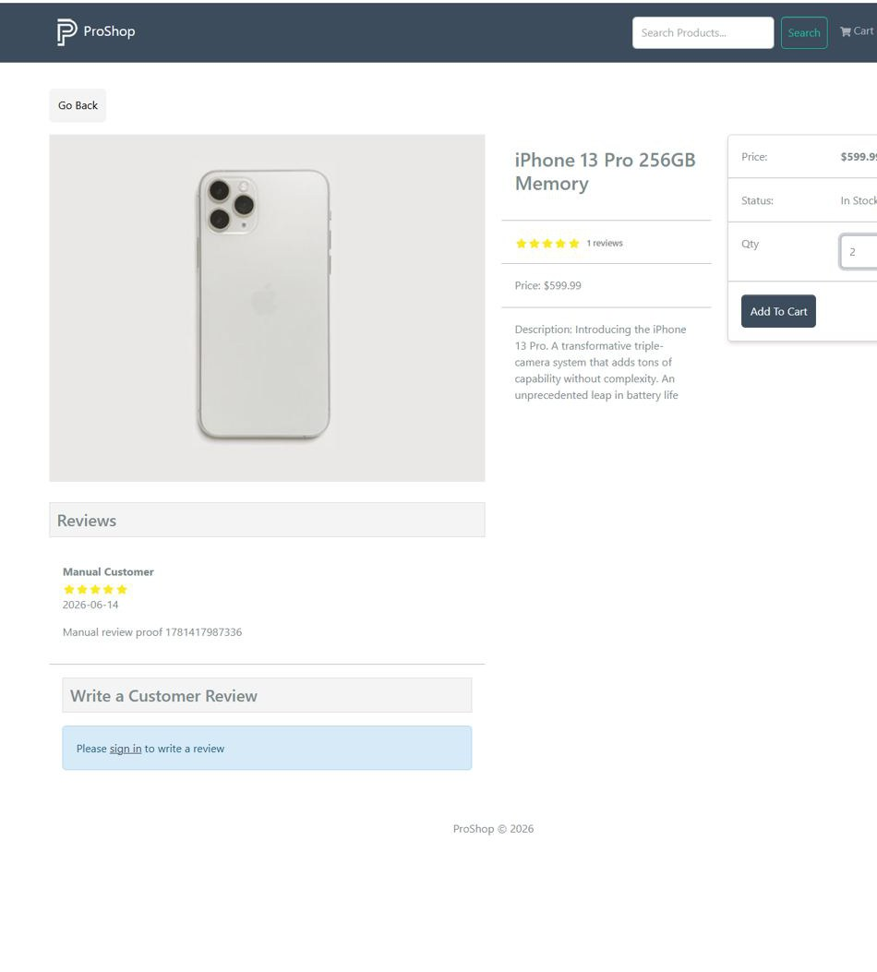Screenshot Proof: MT-04
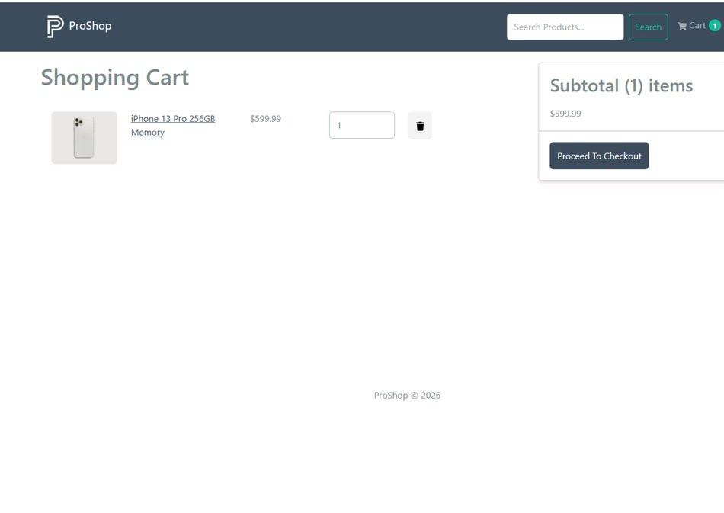Screenshot Proof: MT-05
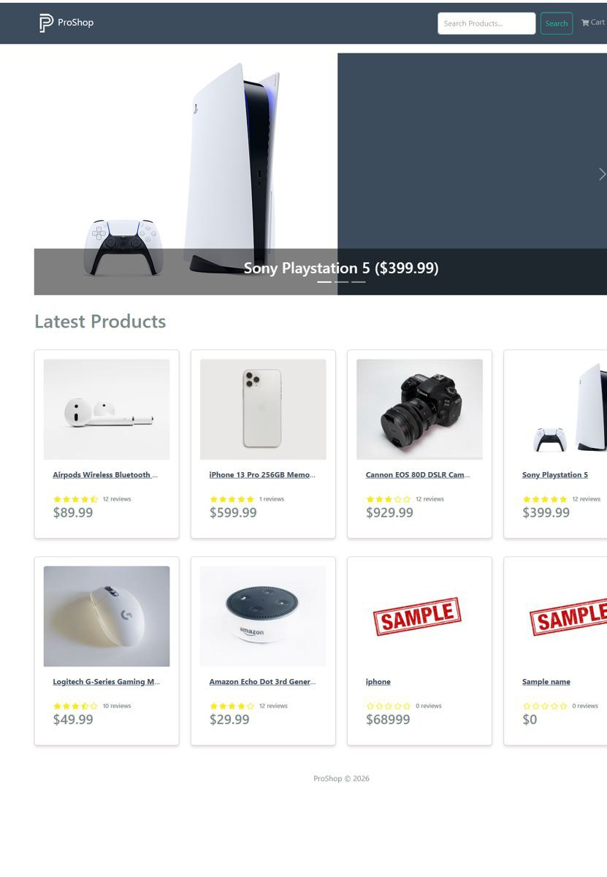
Screenshot Proof: MT- 06
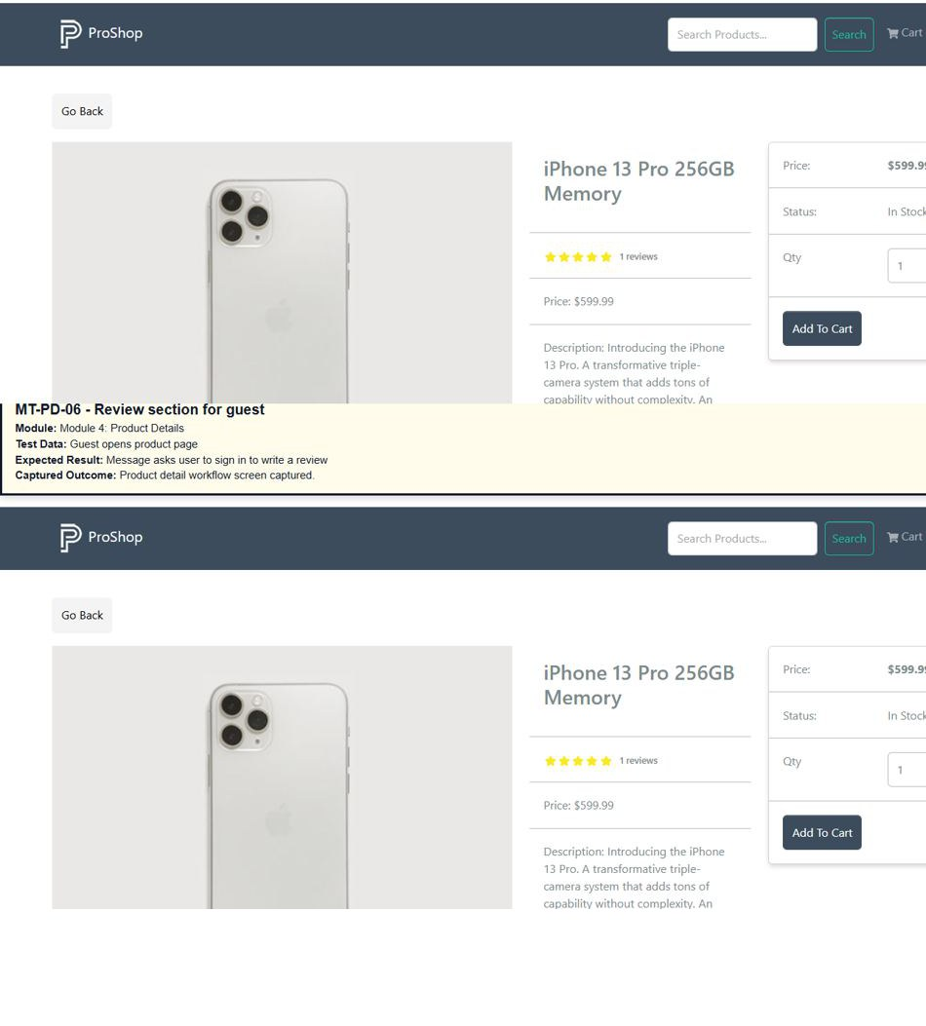Screenshot Proof: MT-07
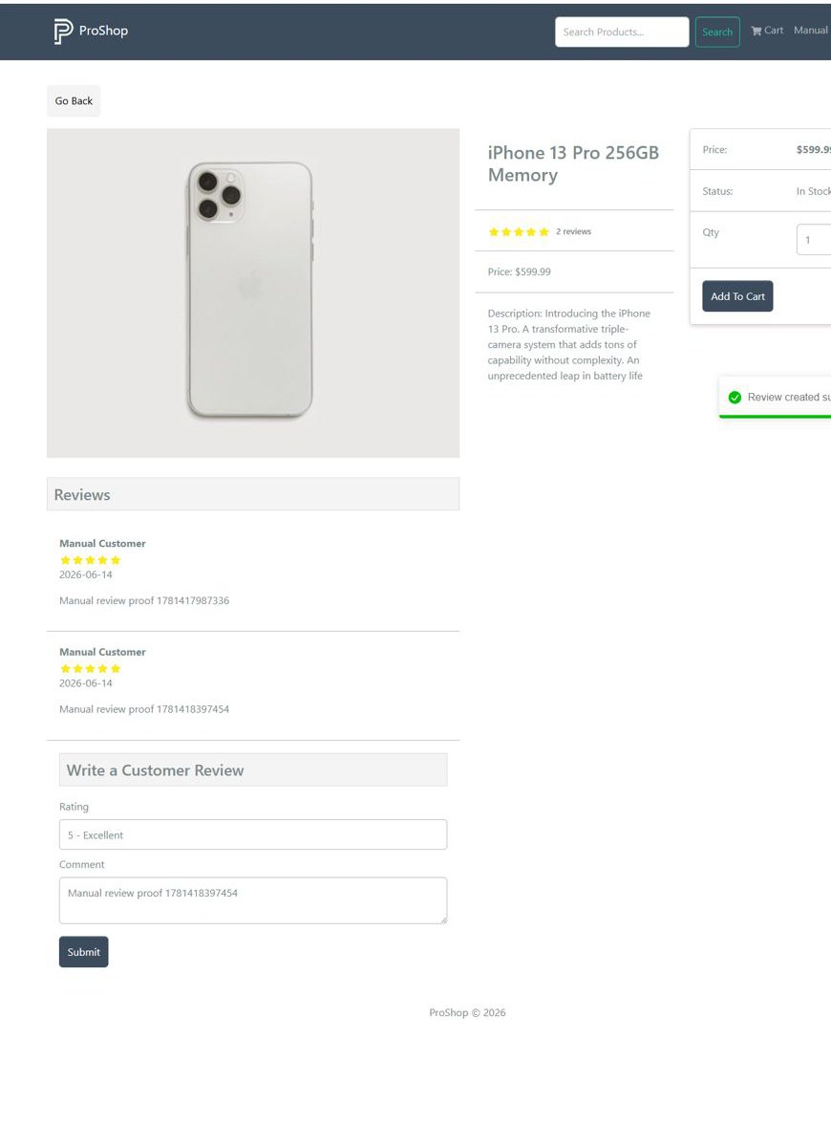Screenshot Proof: MT-08

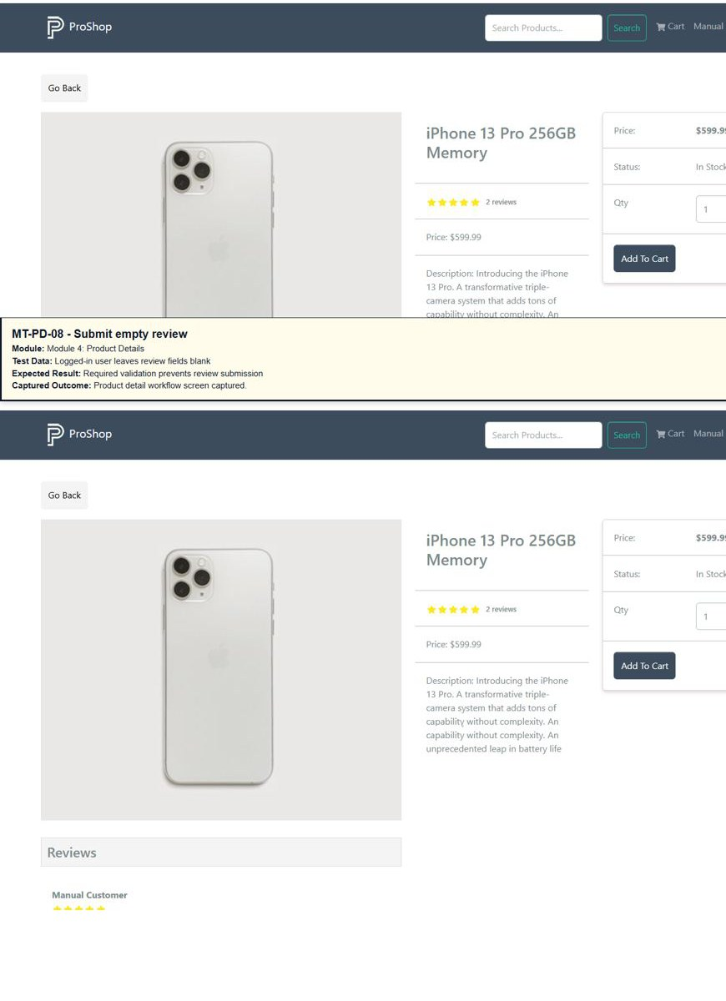

Module 5: Search Product
TC ID | Test Case | Test Data | Expected Result | Status
MT-01 | Search valid keyword | iphone | Matching iPhone product is displayed | Executed
MT-02 | Search another valid keyword | camera | Matching camera product is displayed | Executed
MT-03 | Search partial keyword | iph | Related matching products are displayed | Executed
MT-04 | Search uppercase keyword | IPHONE | Search works case-insensitively | Executed
MT-05 | Search non-existing keyword | xyzabc | No matching products are displayed and page remains stable | Executed
MT-06 | Search special characters | @ | System remains stable and no script/error is shown | Executed
MT-07 | Empty search | Blank search field + Search button | Latest products page is shown without error | Executed
MT-08 | Go Back after search | Search keyword then click Go Back | Home/latest products page opens | Executed

Screenshots / Visual Proof
Screenshot Proof: MT-01
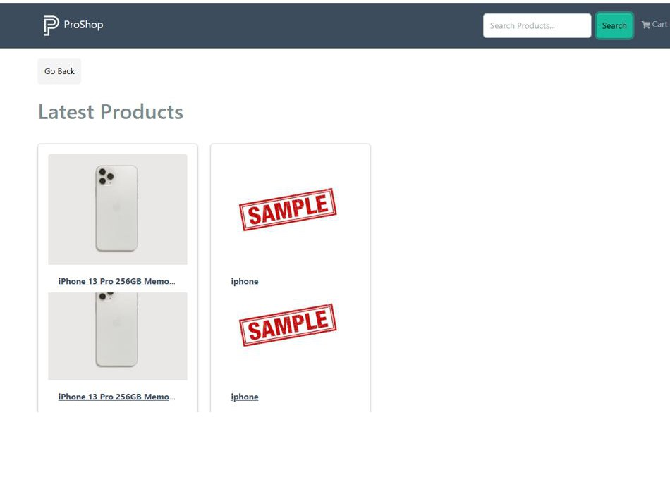Screenshot Proof: MT-02
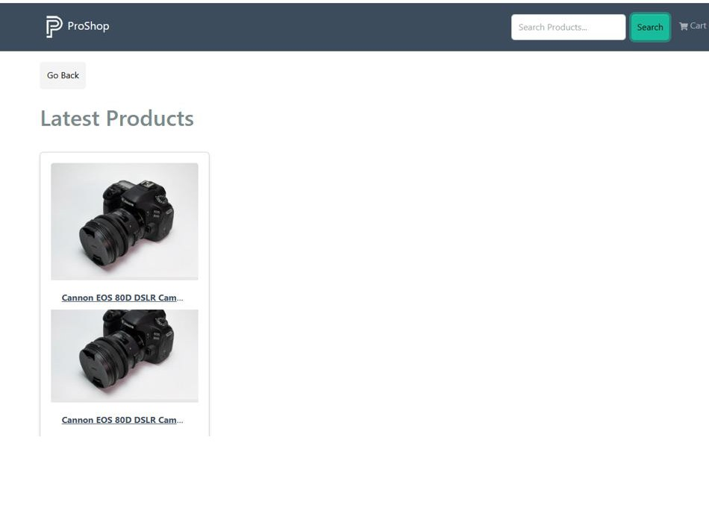Screenshot Proof: MT-03
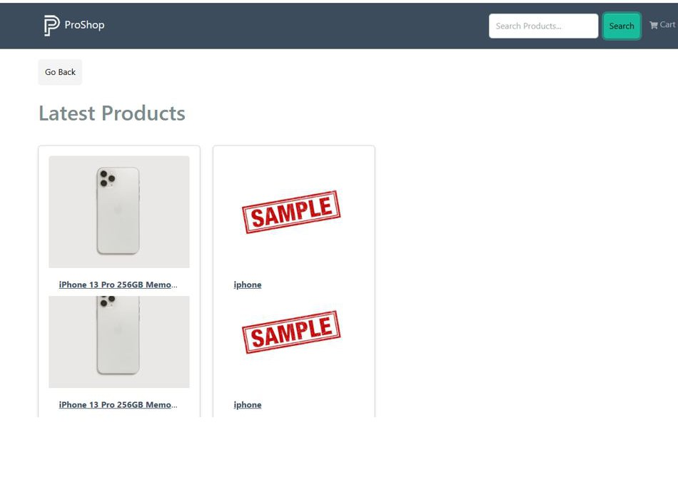Screenshot Proof: MT-04
Screenshot Proof: MT-05
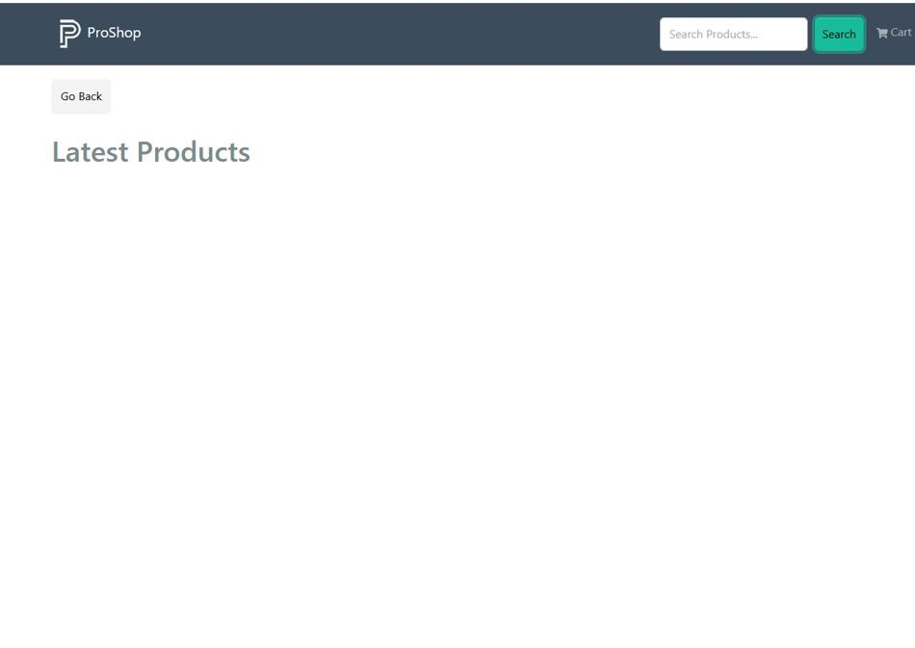Screenshot Proof: MT-06
Screenshot Proof: MT-07
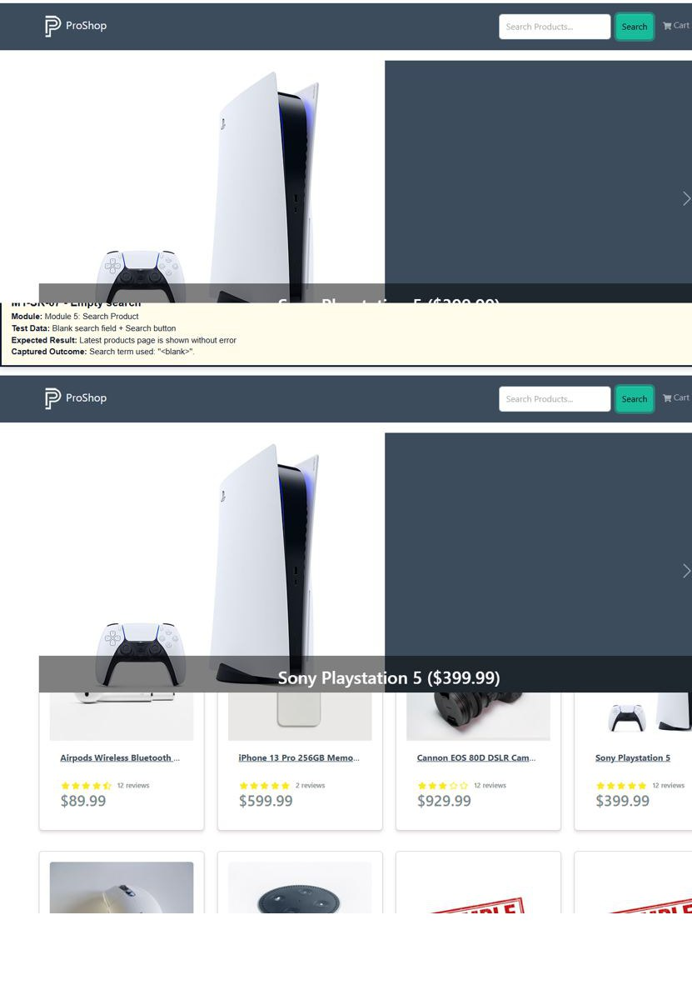
Screenshot Proof: MT-08

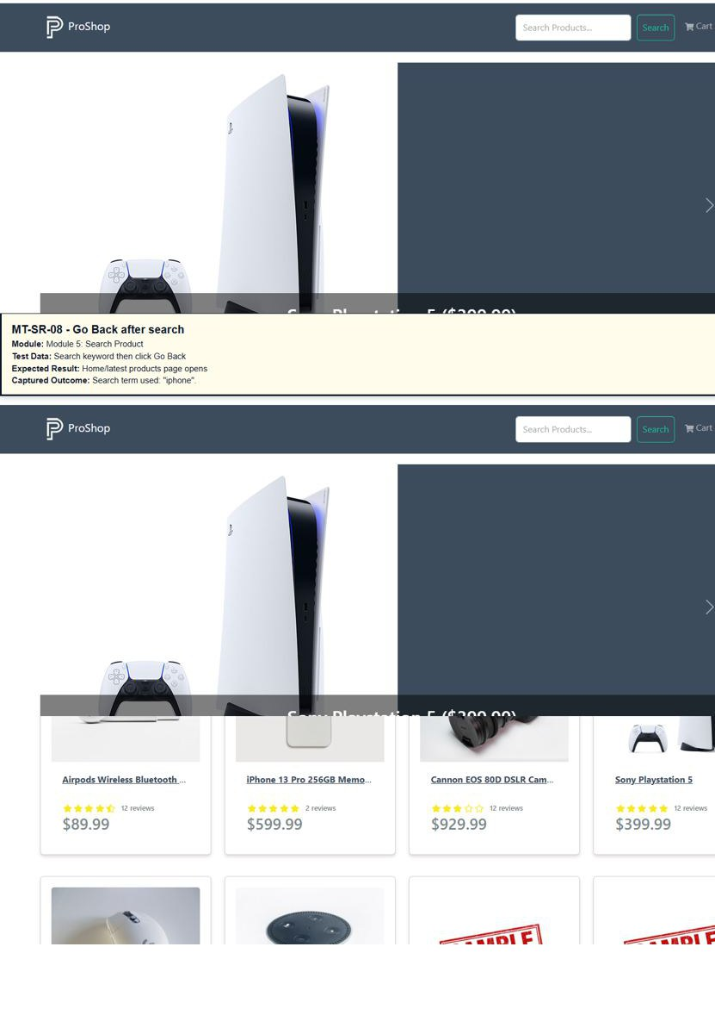

Module 6: Cart Management
TC ID | Test Case | Test Data | Expected Result | Status
MT-CT-01 | Open empty cart | No product added | Cart displays Your cart is empty message | Executed
MT-CT-02 | Add one product | Product qty 1 | Product row is visible in cart with correct price and subtotal | Executed
MT-CT-03 | Update quantity | Change qty from 1 to 2 | Quantity and subtotal update correctly | Executed
MT-CT-04 | Add different product | Add second product | Cart displays both product rows | Executed
MT-CT-05 | Remove one product | Click delete icon | Selected product is removed from cart | Executed
MT-CT-06 | Remove all products | Delete every product row | Cart returns to empty state | Executed
MT-CT-07 | Refresh cart | Refresh browser on cart page | Cart state remains consistent after refresh | Executed
MT-CT-08 | Proceed checkout empty cart | Click Proceed To Checkout when cart empty | Button is disabled or user cannot proceed | Executed

Screenshots / Visual Proof
Screenshot Proof: MT-CT-01
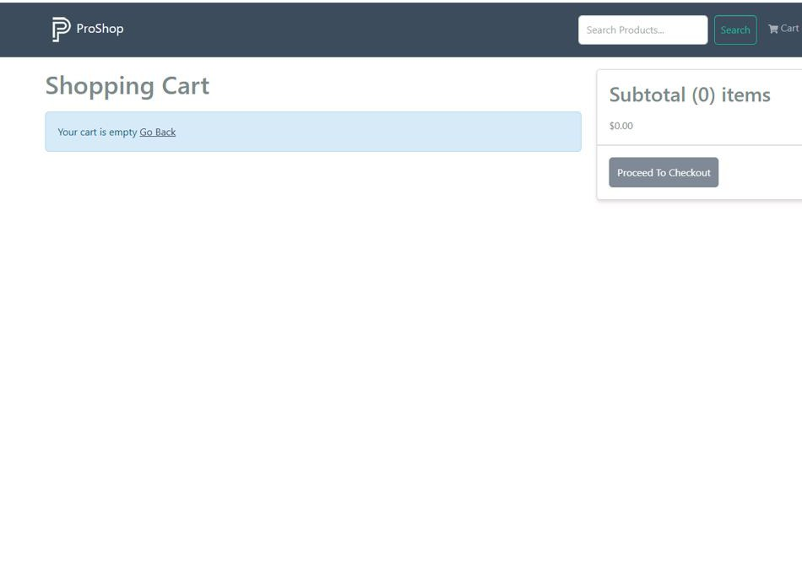Screenshot Proof: MT-02
Screenshot Proof: MT-03
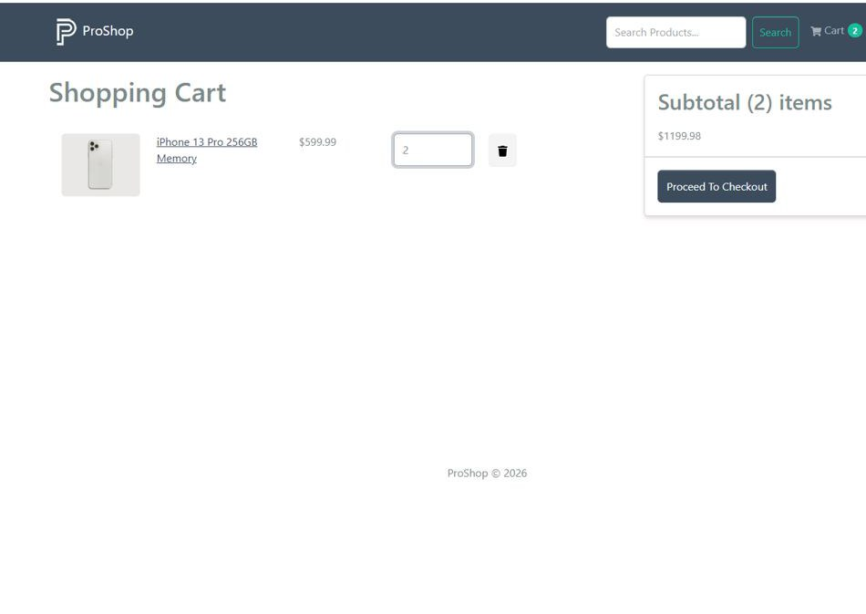Screenshot Proof: MT-04
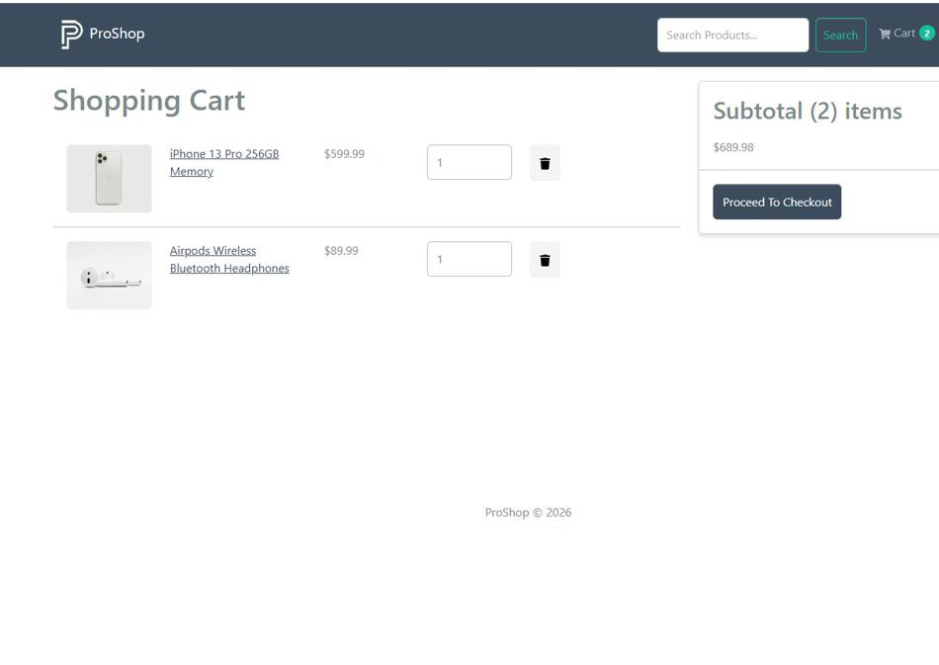Screenshot Proof: MT-05
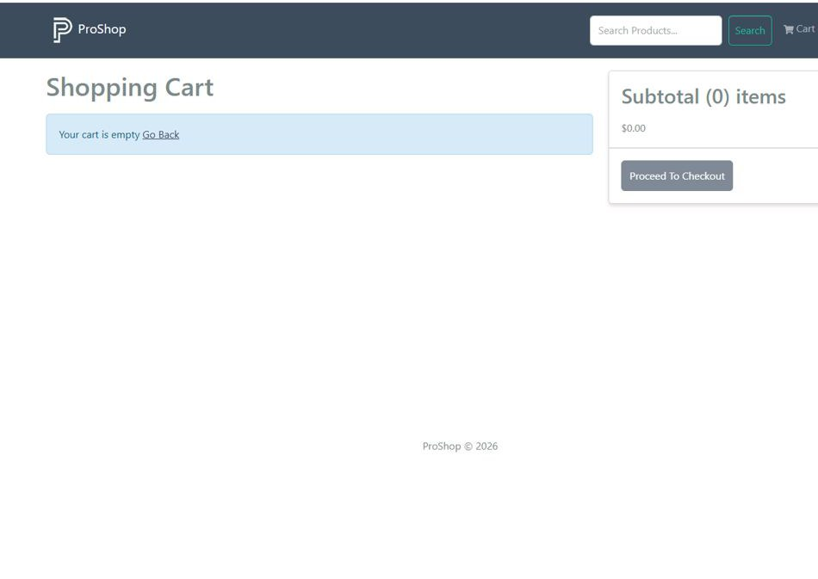Screenshot Proof: MT-06
Screenshot Proof: MT-07
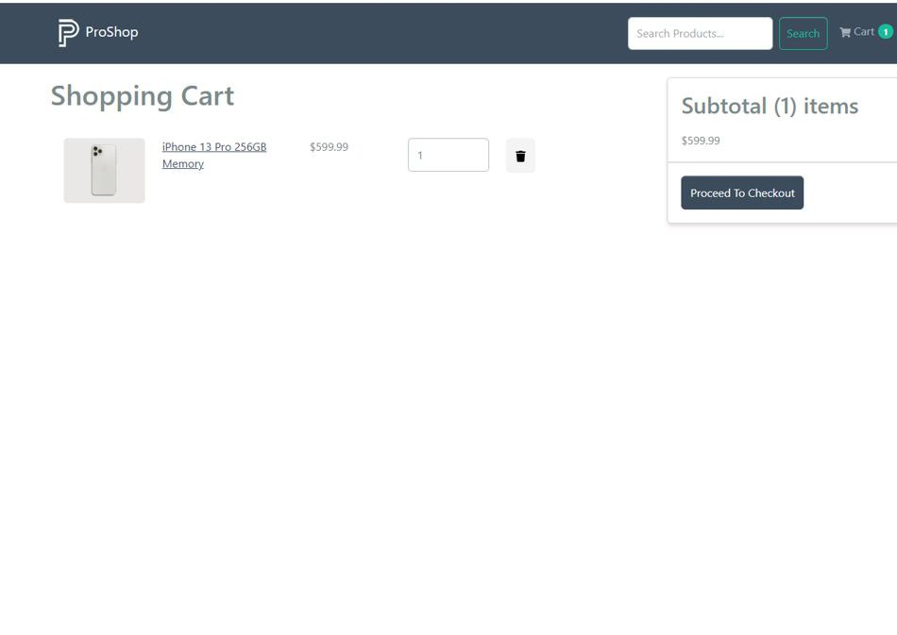Screenshot Proof: MT-08

Module 7: Checkout / Shipping / Payment
TC ID | Test Case | Test Data | Expected Result | Status
MT01 | Checkout as guest | Product in cart + guest user | User is redirected to Sign In page | Executed
MT-02 | Checkout as logged-in user | Product in cart + valid login | Shipping page opens | Executed
MT-03 | Submit valid shipping | Address, city, postal code, country | Payment page opens | Executed
MT-04 | Submit empty shipping | Leave fields blank | Required validation prevents moving forward | Executed
MT-05 | Select payment method | PayPal selected | Place Order page opens | Executed
MT-06 | Verify order summary | Product in cart | Items price, shipping, tax, and total are shown correctly | Executed
MT-07 | Place order | Valid cart + shipping + payment method | Order is created and order detail page opens | Executed
MT-08 | Back from shipping | Browser back after shipping opens | Cart page still shows same cart items | Executed

Screenshots / Visual Proof
Screenshot Proof: MT-01 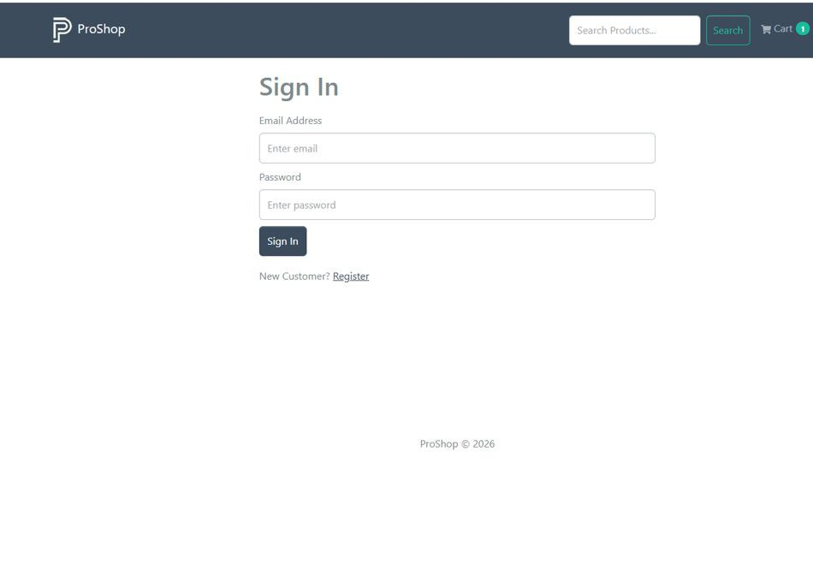Screenshot Proof: MT-02
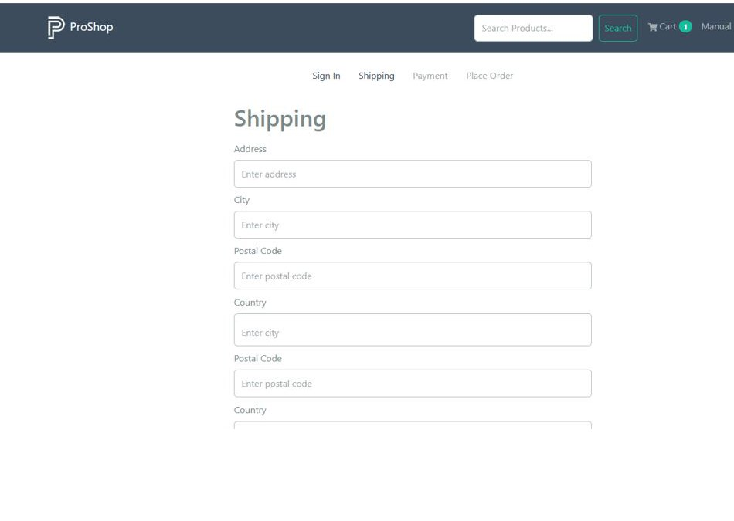Screenshot Proof: MT-03
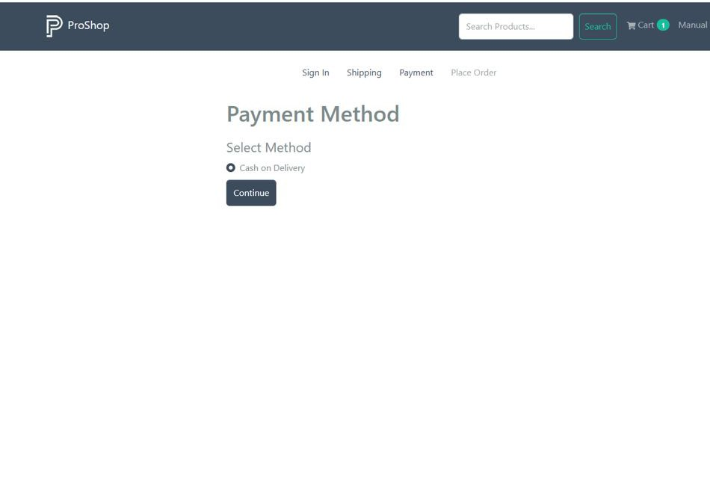Screenshot Proof: MT-04
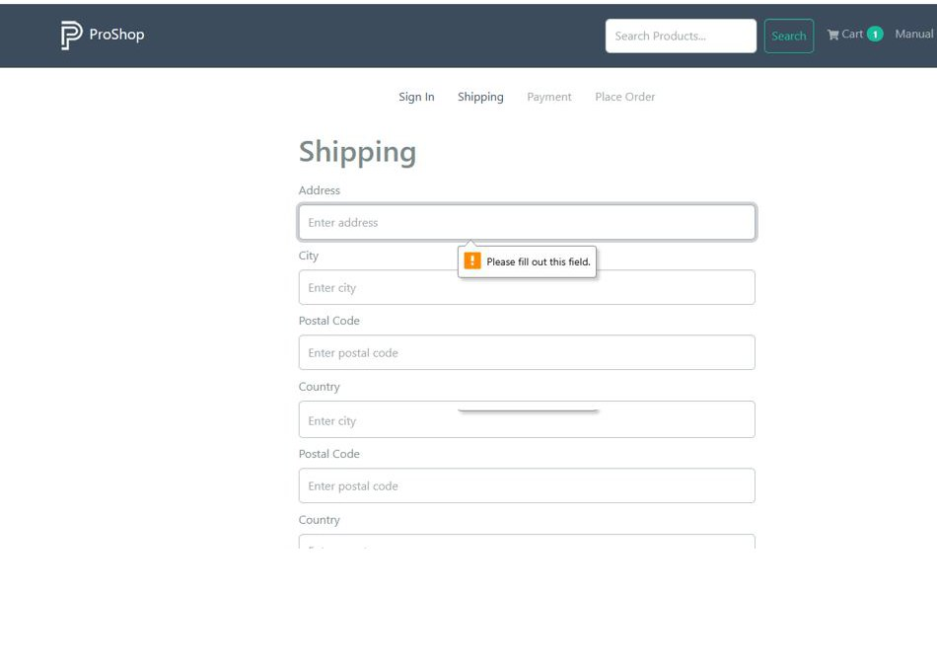Screenshot Proof: MT-05
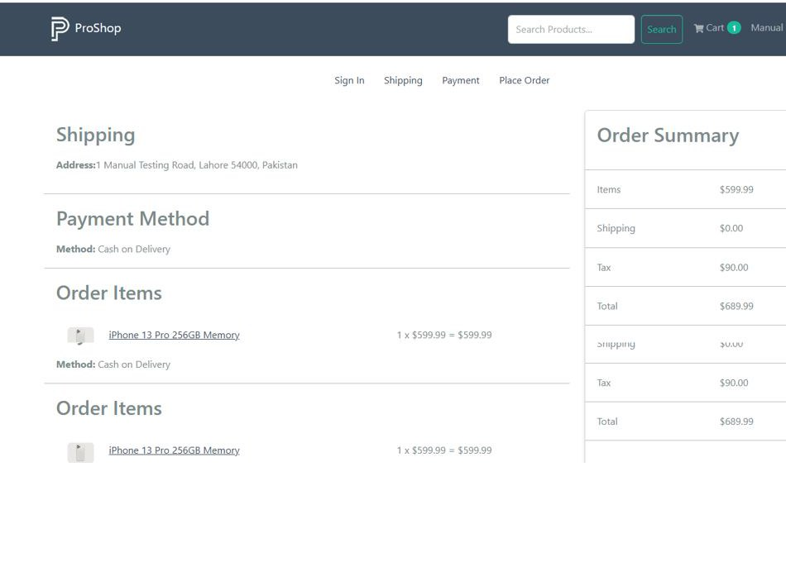Screenshot Proof: MT-06
Screenshot Proof: MT-07
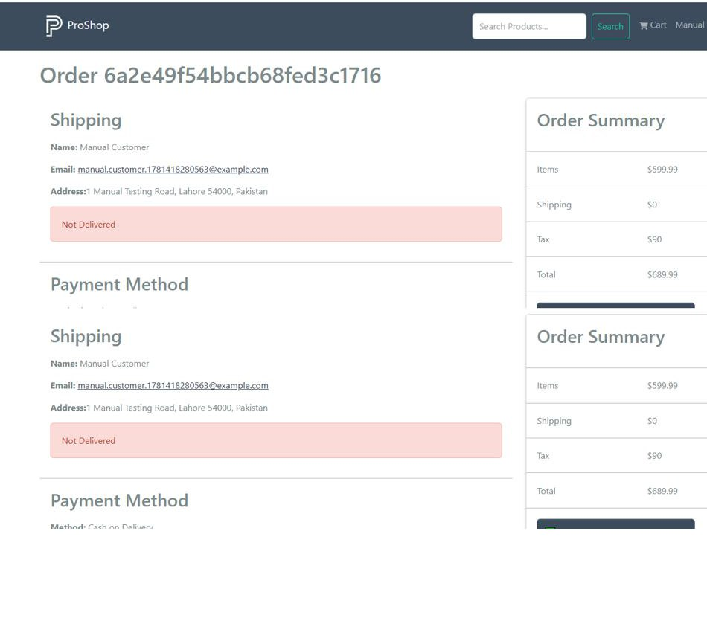Screenshot Proof: MT-08

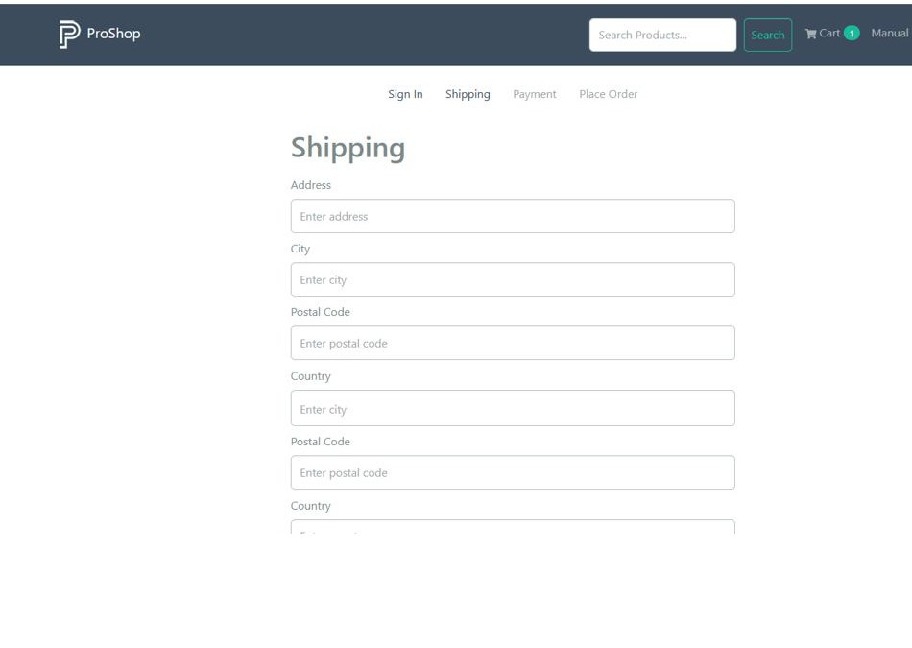Module 8: User Profile / My Orders
TC ID | Test Case | Test Data | Expected Result | Status
MT-01 | Open profile | Logged-in customer clicks Profile | Profile page opens with user details | Executed
MT-02 | Update name | Change name field and submit | Profile name is updated successfully | Executed
MT-03 | Update email | Change email field and submit | Profile email is updated or validation is shown | Executed
MT-04 | Password mismatch in profile | Password and confirm password different | Profile update is rejected | Executed
MT-05 | View my orders | Customer with orders | My Orders table is displayed | Executed
MT-06 | Open order details | Click Details in My Orders | Selected order detail page opens | Executed
MT-07 | Profile after refresh | Refresh profile page | User remains authenticated and profile data remains visible | Executed
MT-08 | Logout from profile | Click Logout | User session ends and protected pages are no longer accessible | Executed

Screenshots / Visual Proof
Screenshot Proof: MT-01
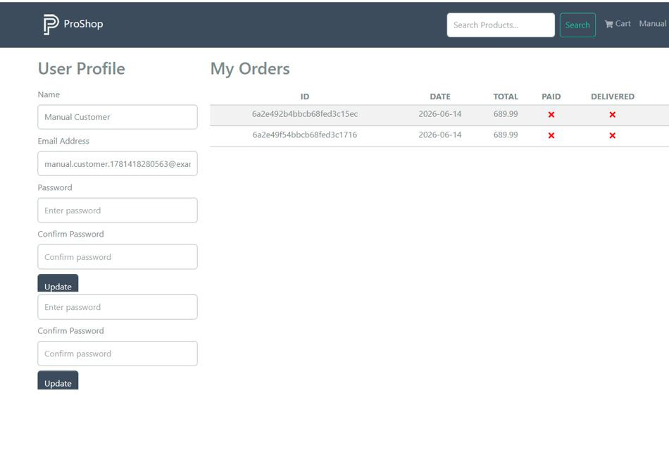Screenshot Proof: MT-02
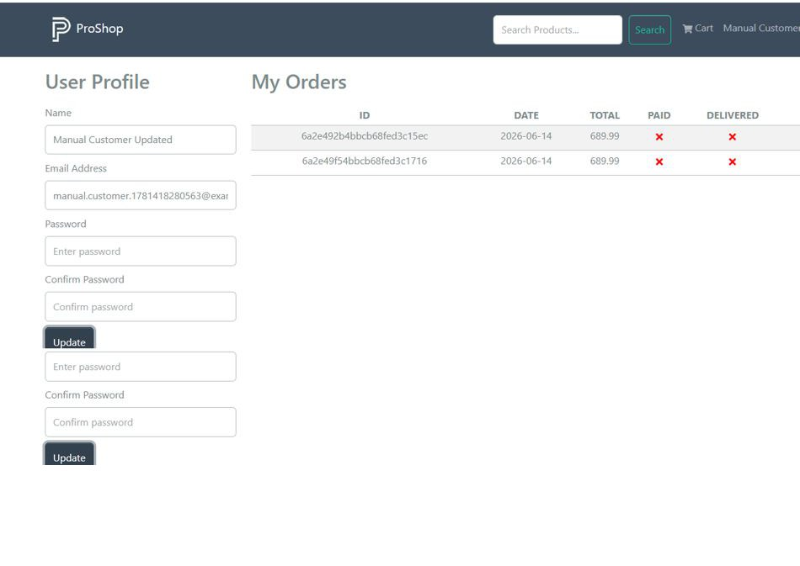Screenshot Proof: MT-03
Screenshot Proof: MT-04
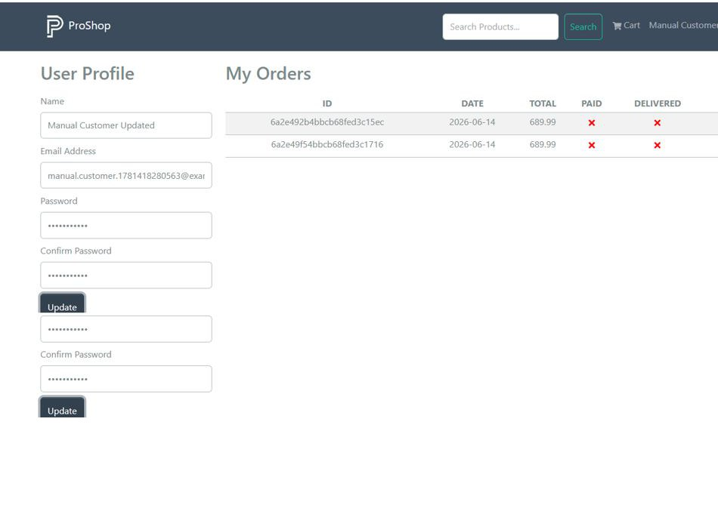Screenshot Proof: MT-05
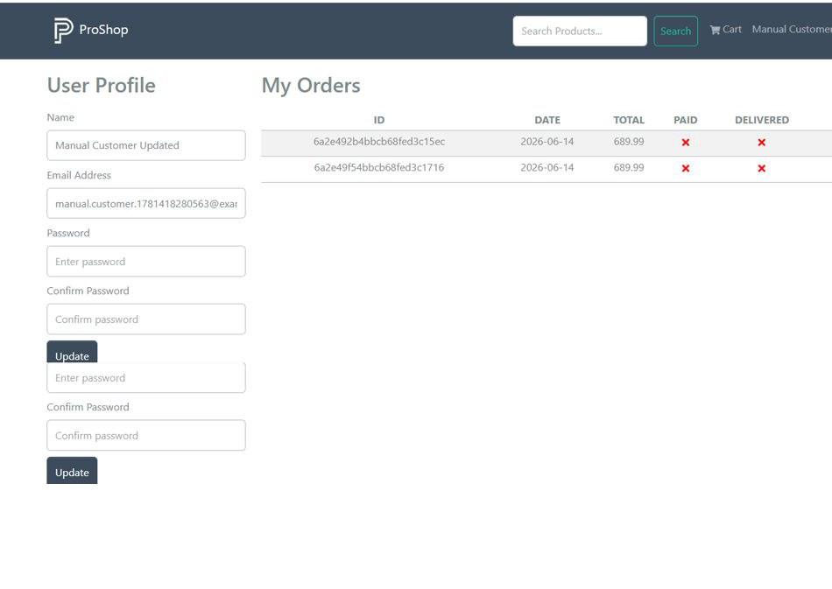Screenshot Proof: MT-06
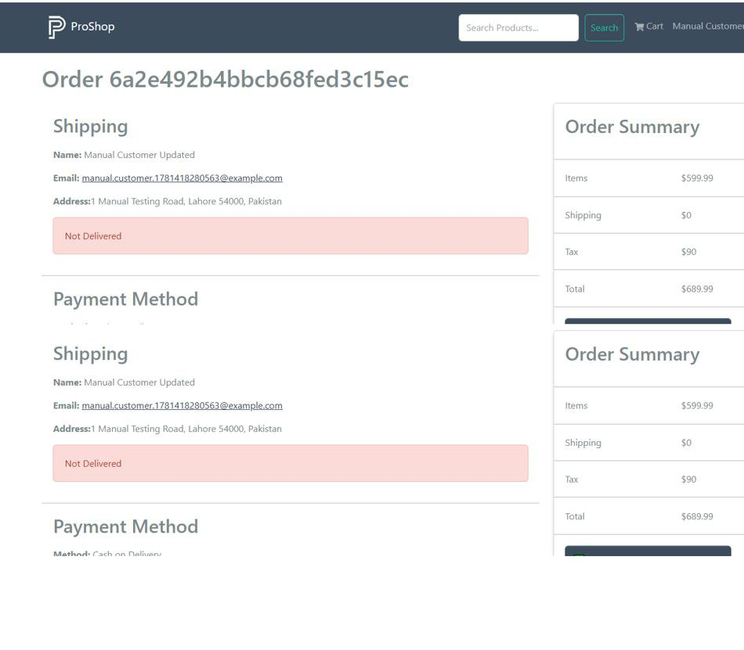Screenshot Proof: MT-07
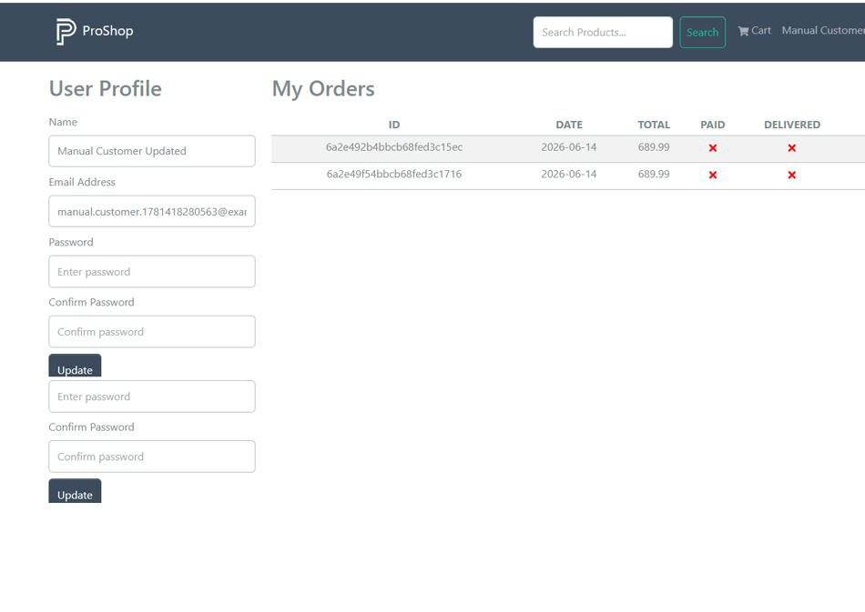Screenshot Proof: MT-08

Module 9: Admin Product Management
TC ID | Test Case | Test Data | Expected Result | Status
MT-01 | Open product list | Admin -> Products | Admin product list page opens | Executed
MT-02 | Verify product columns | Product list table | ID, Name, Price, Category, Brand, and action columns are visible | Executed
MT-03 | Create product | Click Create Product | New sample product is created or confirmation is shown | Executed
MT-04 | Edit product | Click edit icon | Product edit page opens with editable product fields | Executed
MT-05 | Update product fields | Change name, price, brand, category, stock, description | Product updates successfully | Executed
MT-06 | Upload product image | Choose image file | Image path updates or upload confirmation appears | Executed
MT-07 | Delete product | Click delete icon and confirm | Product is removed from product list | Executed
MT-08 | Normal user product access | Customer opens /admin/productlist | User is redirected or denied access | Executed

Screenshots / Visual Proof
Screenshot Proof: MT-01
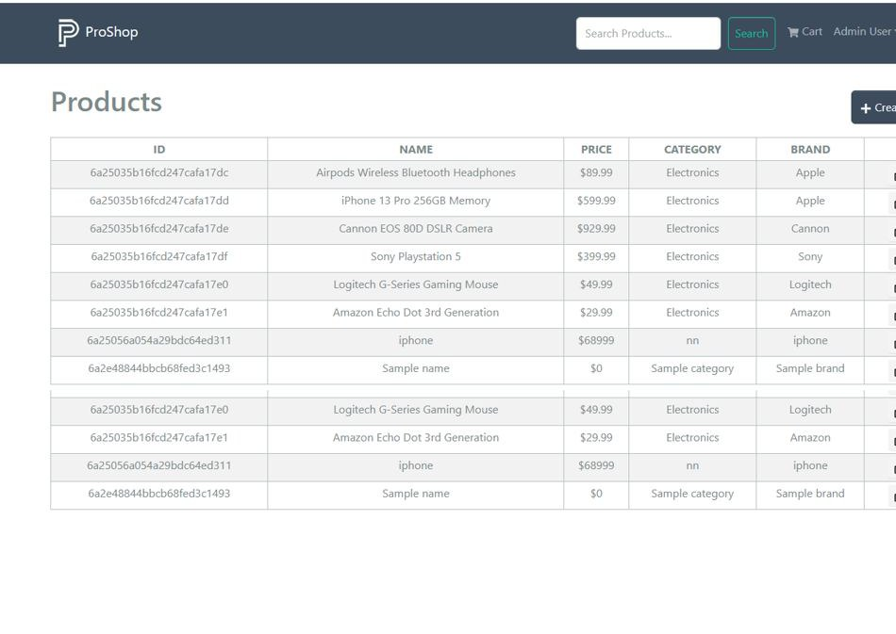Screenshot Proof: MT-02
Screenshot Proof: MT-03
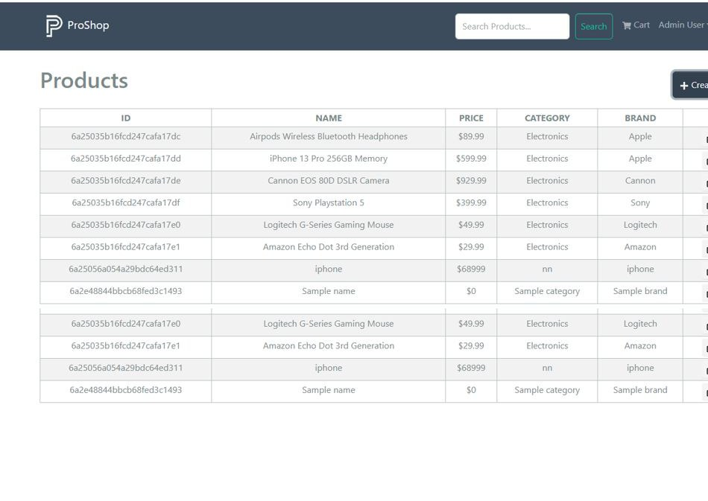Screenshot Proof: MT-04
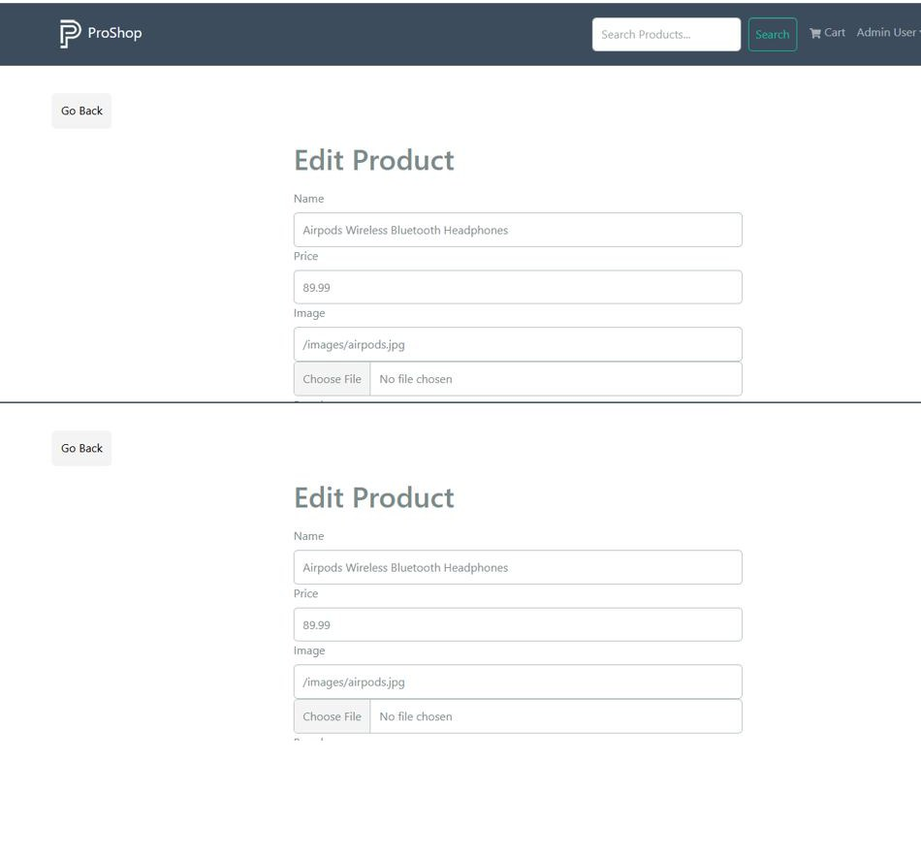Screenshot Proof: MT-05
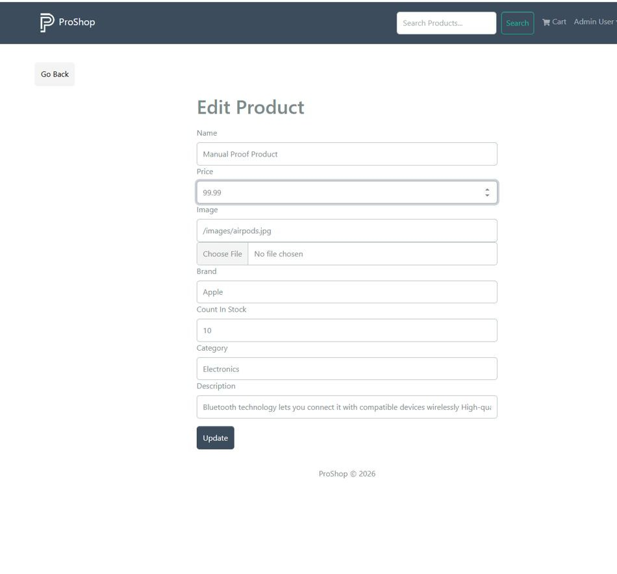Screenshot Proof: MT-06
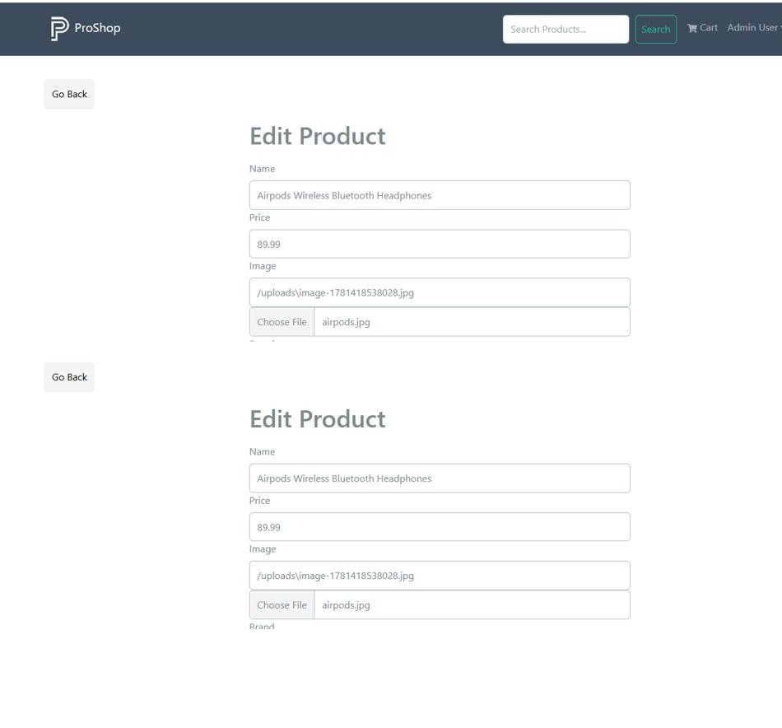Screenshot Proof: MT-07
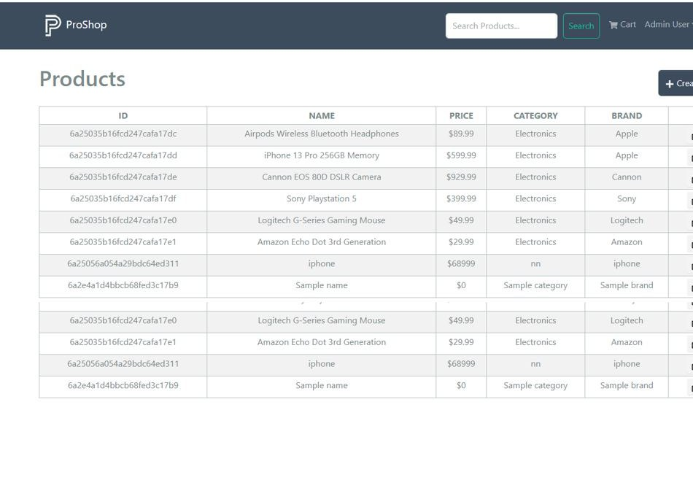Screenshot Proof: MT-08

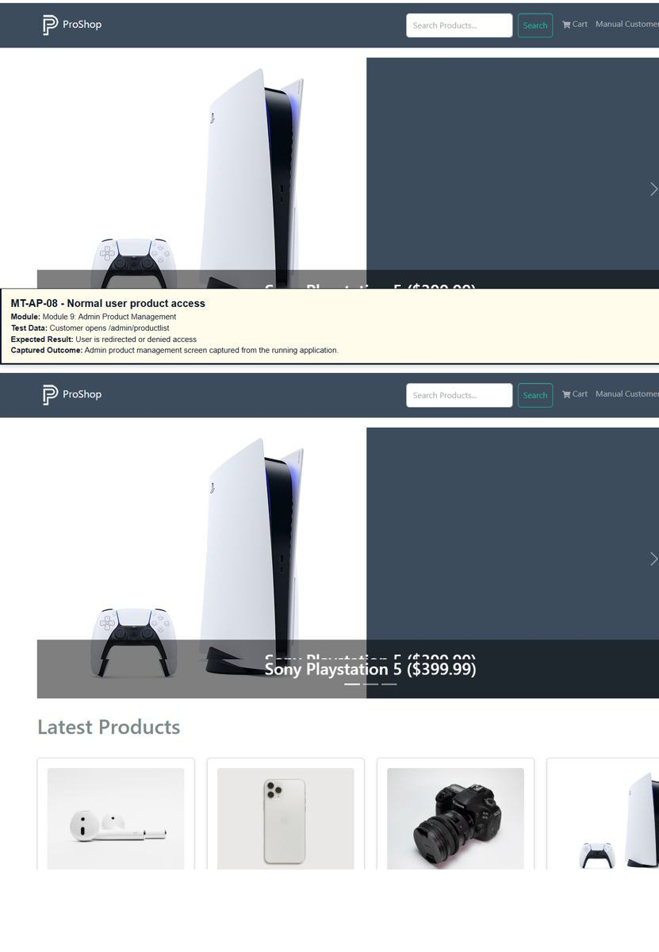

Module 10: Admin User Management
TC ID | Test Case | Test Data | Expected Result | Status
MT-01 | Open user list | Admin -> Users | Admin user list page opens | Executed
MT-02 | Verify user columns | User list table | ID, Name, Email, Admin status, and actions are visible | Executed
MT-03 | Open user edit | Click edit icon for normal user | User edit page opens | Executed
MT-04 | Update user role | Check/uncheck admin status and submit | User role is updated correctly | Executed
MT-05 | Delete normal user | Click delete icon and confirm | Normal user is removed | Executed
MT-06 | Prevent admin delete | Attempt to delete admin user | Admin user cannot be deleted | Executed
MT-07 | Guest user list access | Guest opens /admin/userlist | Guest is redirected to Sign In page | Executed
MT-08 | Customer user list access | Customer opens /admin/userlist | Customer is denied or redirected | Executed

Screenshots / Visual Proof
Screenshot Proof: MT-AU-01 - Open user list
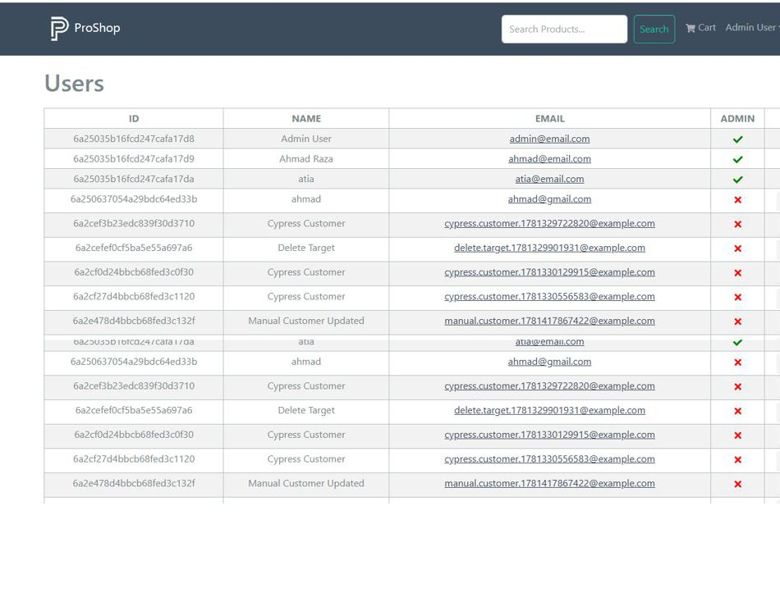Screenshot Proof: MT-02
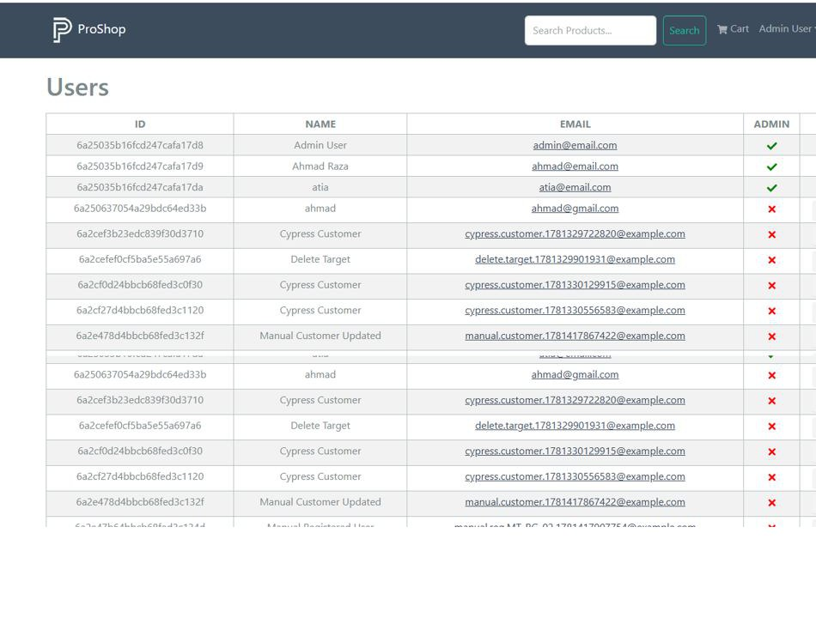Screenshot Proof: MT-03
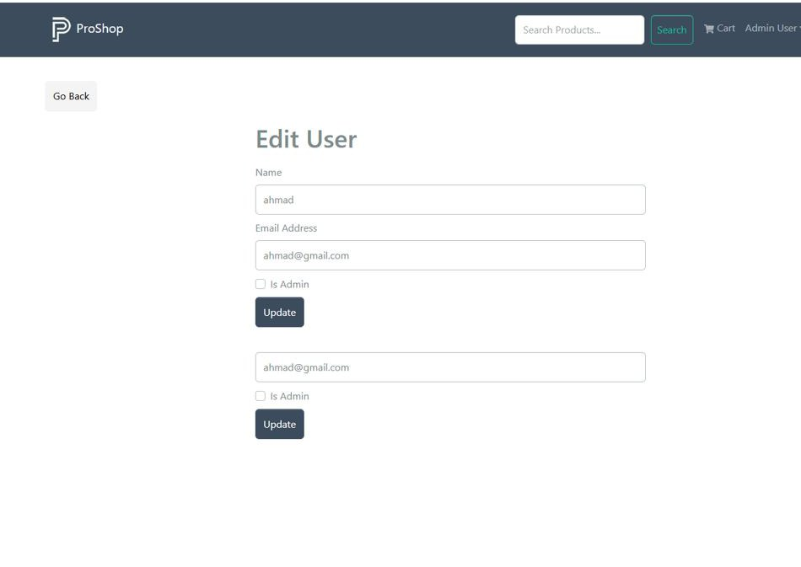Screenshot Proof: MT-04
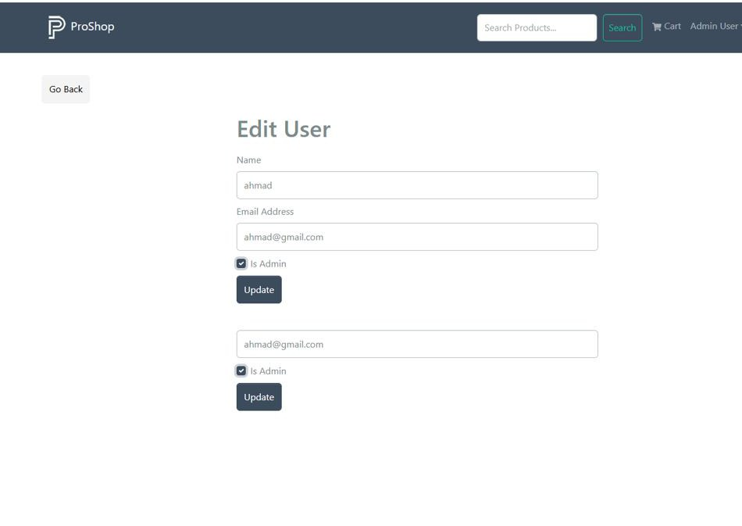Screenshot Proof: MT-05
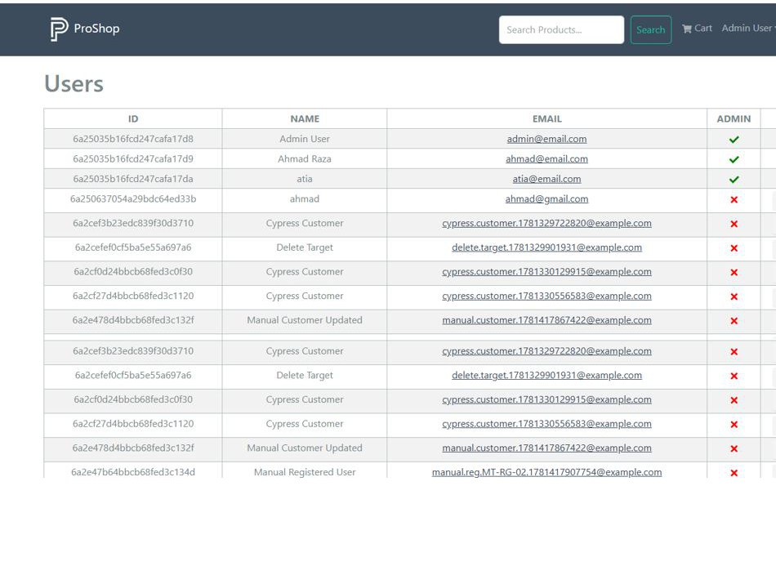Screenshot Proof: MT-06
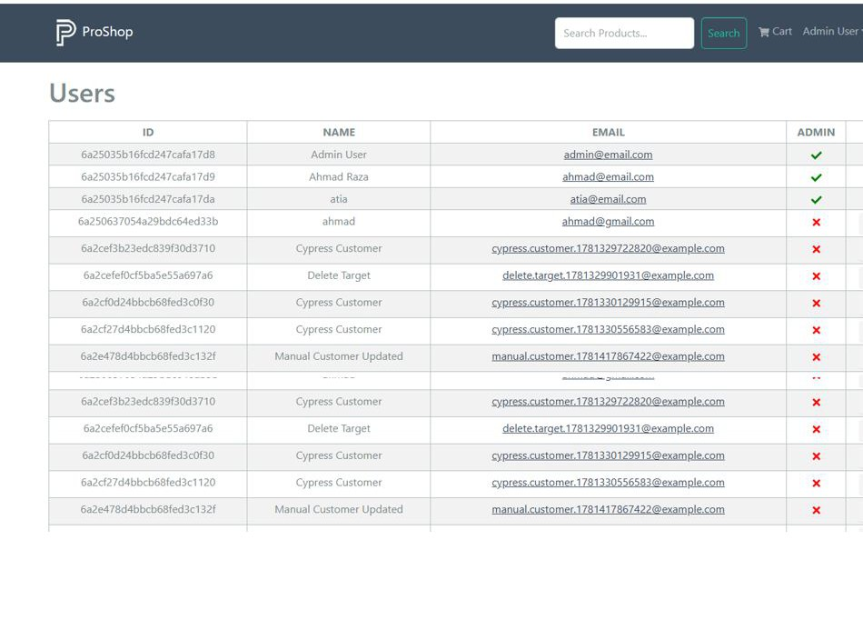Screenshot Proof: MT-07
Screenshot Proof: MT-08

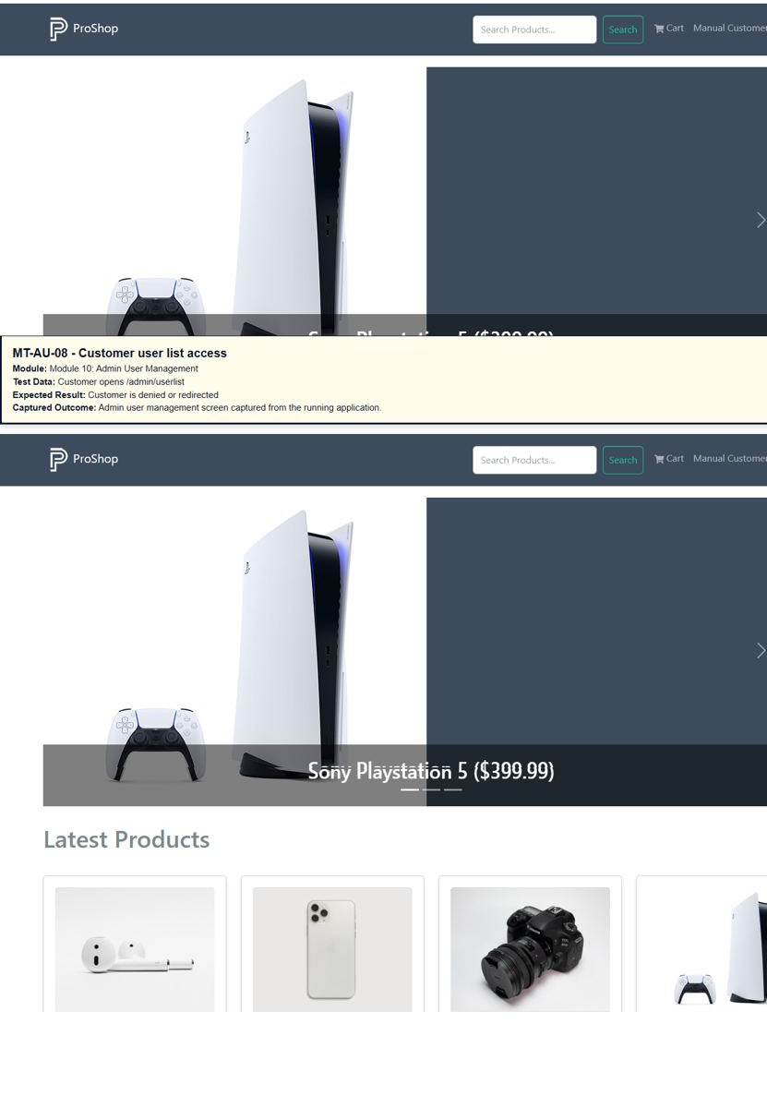

Module 11: Admin Order Management
TC ID | Test Case | Test Data | Expected Result | Status
MT-01 | Open order list | Admin -> Orders | Admin order list page opens | Executed
MT-02 | Verify order columns | Order list table | ID, User, Date, Total, Paid, Delivered, and Details columns are visible | Executed
MT-03 | Open order details | Click Details | Order detail page opens | Executed
MT-04 | Mark delivered | Admin clicks Mark As Delivered | Order delivered status is updated | Executed
MT-05 | Order list refresh | Refresh admin order list | Order data remains visible | Executed
MT-06 | Normal user order list access | Customer opens /admin/orderlist | Customer is denied or redirected | Executed
MT-07 | Guest order list access | Guest opens /admin/orderlist | Guest is redirected to Sign In page | Executed
MT-08 | Back from order detail | Click browser back | Admin returns to order list page | Executed

Screenshots / Visual Proof
Screenshot Proof: MT-01
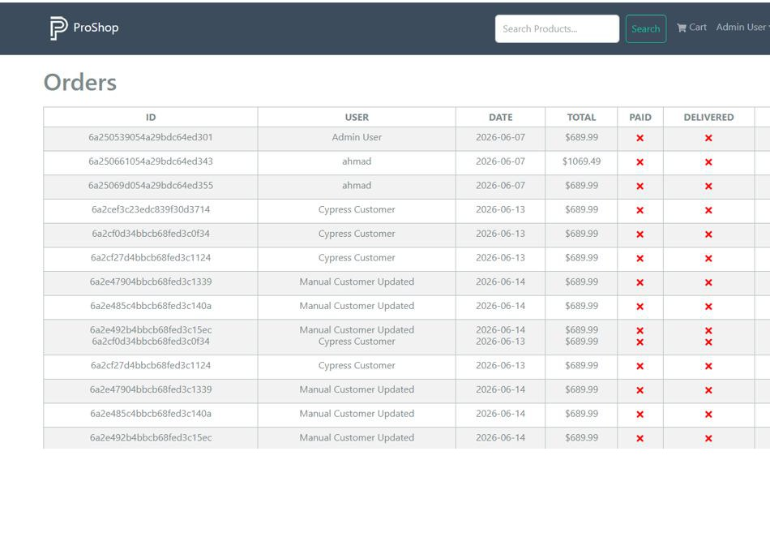Screenshot Proof: MT-02
Screenshot Proof: MT-03
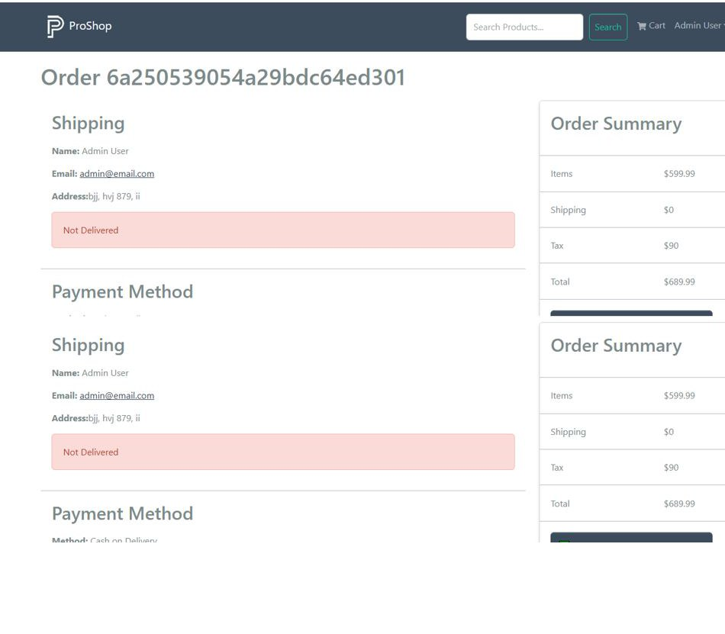Screenshot Proof: MT-04
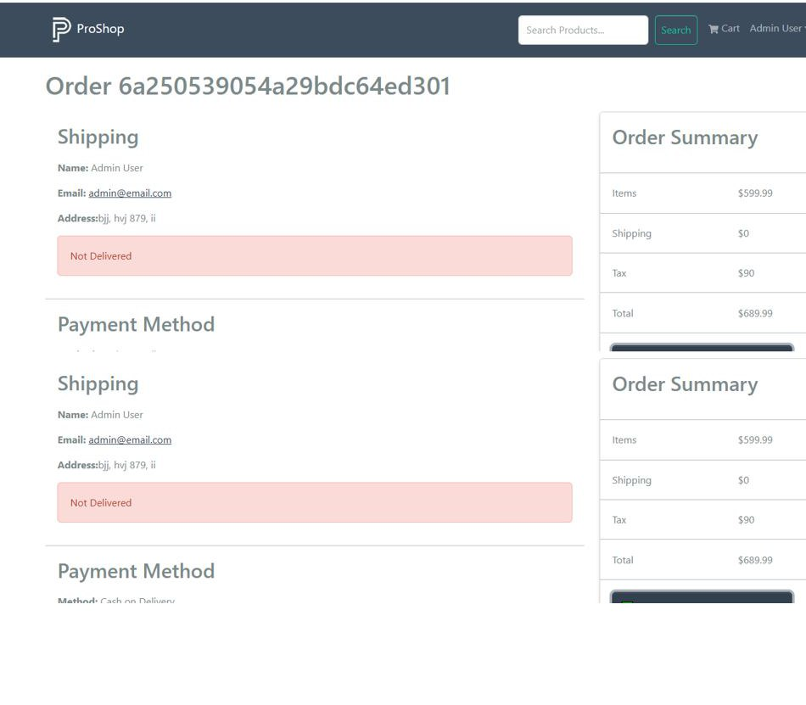Screenshot Proof: MT-05
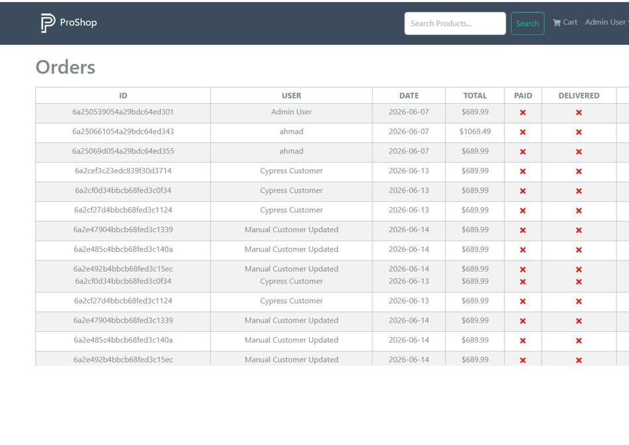Screenshot Proof: MT-06
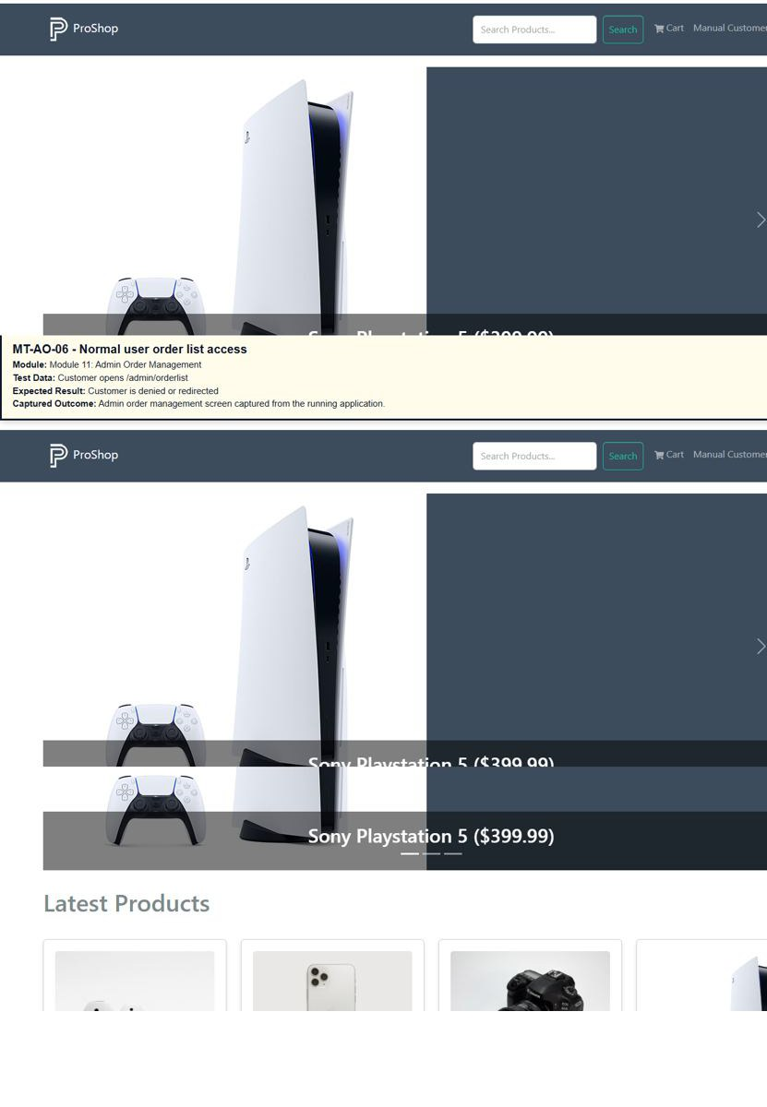

Screenshot Proof: MT-07
Screenshot Proof: MT-08

Module 12: Security / Session / Usability
TC ID | Test Case | Test Data | Expected Result | Status
MT-01 | Direct protected URL as guest | Open /profile without login | User is redirected to Sign In page | Executed
MT-02 | Direct admin URL as guest | Open /admin/userlist without login | Guest is redirected to Sign In page | Executed
MT-03 | Direct admin URL as customer | Customer opens /admin/productlist | Customer is blocked or redirected | Executed
MT-04 | Browser back after logout | Logout then press browser back | Protected/admin page is not accessible | Executed
MT-05 | Refresh after login | Logged-in user refreshes page | Session remains valid and menu stays visible | Executed
MT-06 | XSS input check | <script>alert('XSS')</script> in search/login | Script is not executed and page remains secure | Executed
MT-07 | Responsive home page | Open page on mobile viewport | Header, product cards, and cart link remain usable | Executed
MT-08 | Broken route handling | Open invalid URL | Application handles route without crashing | Executed

Screenshots / Visual Proof
Screenshot Proof: MT-01
Screenshot Proof: MT-02
Screenshot Proof: MT-03
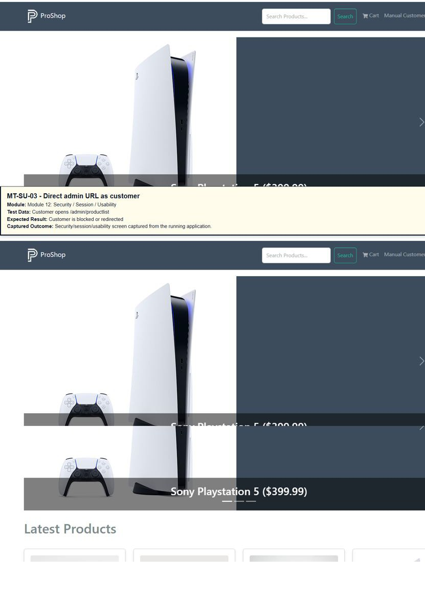
Screenshot Proof: MT-04
Screenshot Proof: MT-05
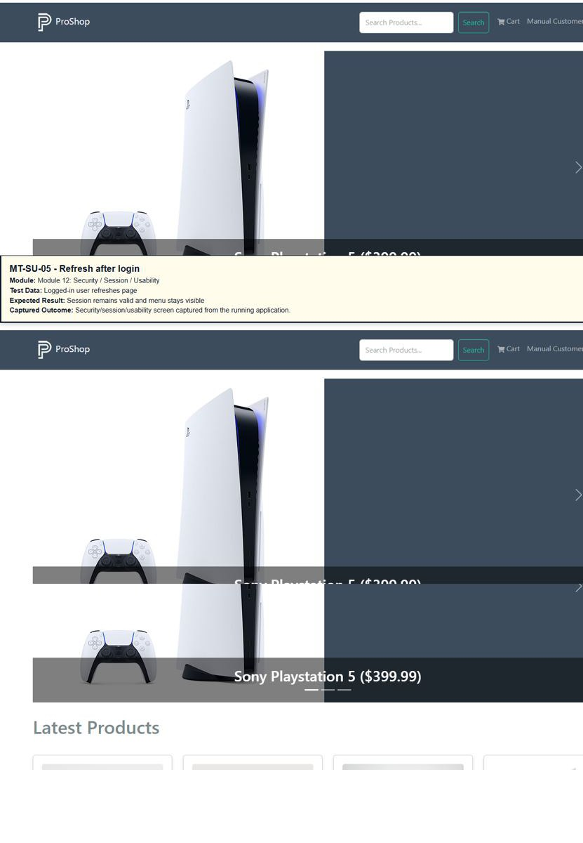
Screenshot Proof: MT-06
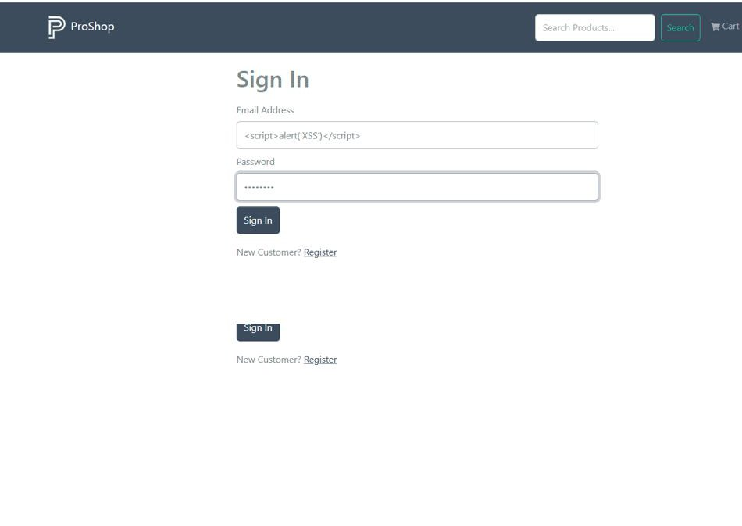 Screenshot Proof: MT-08
